Success at Last
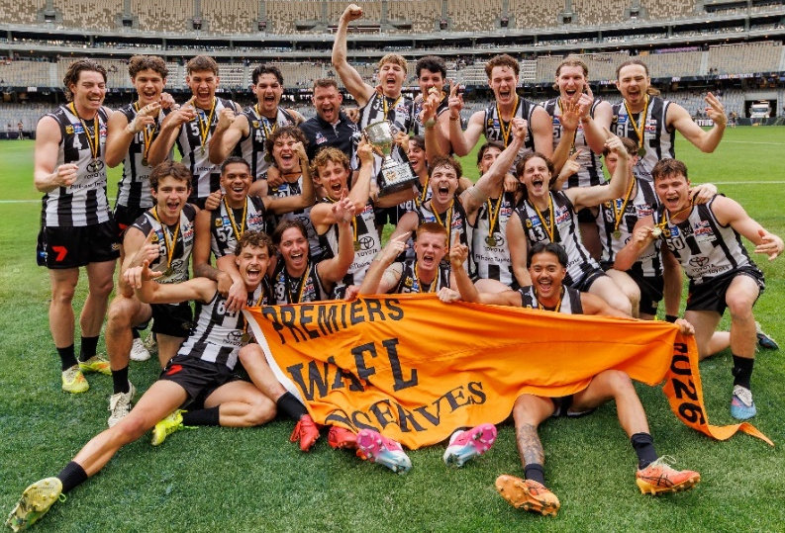
The Reserves took out the 2026 Grand Final against West Perth in what was a nail-biting finish. Having beaten East Perth in the Second Semi to progress to the Grand Final and an in form West Perth coming from fifth place, this was not going to be an easy task. West Perth kicked the first goal before Swans gained their composer and took control of the quarter, although the scoreboard didn’t reflect this with inaccurate kicking, 4.5 to 2.2. Swans had the ascendancy for the better part of the second term but inaccurate kicking, 1.6 to 2.2, saw them only up by 13-points at the long break. The third term was an even affair with the Falcons outscoring Swans 3.3 to 2.3 and go into the last break only 7-points down. With the final term been a straight 28 minutes, no time-on, the pressure was on. Both sides had kicked 2 goals apiece going into the later stages of the term with Swans holding an 11-point lead. The urgency of West Perth was noticeable with their play-on at all costs nature and at the 27.13-minute mark they finally kicked a goal to reduce the deficit to 4-points. With the clock still kicking, by the time the ball was returned to the centre and the umpire threw the ball up there was only 15 seconds left on the clock. The young Swans locked the ball down for the final few seconds and the win was theirs. Luke Cotellessa won the Merv McIntosh Medal for best afield. Congratulations to the Reserves Coach John Armstrong and his coaching staff along with the players for a great achievement.

Vale – Steve Bakes
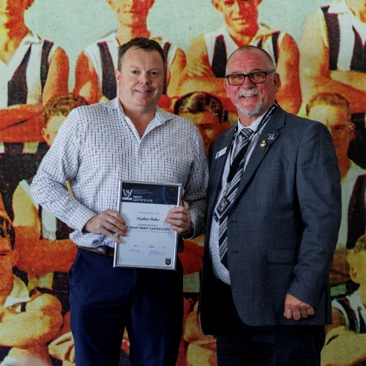
The Swansmen extend our sympathy to the Bakes family on the sad passing of Steve, a much-loved and highly valued member of the Swansmen family. Steve gave more than 16 years of dedicated service to the Swansmen and was a current member of the Swansmen Committee. Over many years, he generously gave his time and energy to the Club, serving in a number of important roles including Secretary, Treasurer and Vice President. His contribution went well beyond the positions he held. Steve was someone who cared deeply about the Swans and was always willing to contribute, support others and play his part in strengthening the Club and the Swansmen community. His longstanding commitment was recognised with a 10-Year Service Certificate in 2025, an acknowledgement of which Steve was immensely proud and a fitting reflection of what the Club meant to him. Most importantly, Steve was a devoted husband and father. Our deepest sympathies are with his wife Sherryn, their two children, and Steve’s wider family and friends at this incredibly difficult time. Steve will be remembered with great affection and gratitude by everyone at Swan Districts. His many years of service, friendship and commitment to the black and white will not be forgotten.
RIP Steve
Once a Swan, always a Swan

Trevor Hoy (President)

OCTOBER DINNER MEETING - Away Dinner
Tuesday 20th OCTOBER 2026 6:30pm
The Stirling Arms Hotel

Come along and enjoy a good old pub meal, a coldie, a yarn with your mates and maybe even a game of pool at the away dinner at the Stirling Arms Hotel.
Numbers must be confirmed before Tuesday 13th October by one of the following methods:

RSVP via the online link at RSVP or phone Trevor Hoy on 0405 453 042

Please note, that if you RSVP 'Yes' to a dinner and do not attend the Swansmen still have to pay for your meal.

Invite a Guest
We ask all members to RSVP to the dinners early and we ask that you endeavour to bring along a guest so that we get good numbers and increase our profile.

Maurice Embley Medal Night

The Maurice Embley Medal Night for the All-Abilities was held on Friday 4th September at the Club. A memorable night was had by players, family and friends. The Maurice Embley Medal for Most Valuable player for 2026 went to Jackson Foskett. This is Jackson’ first Maurice Embley Medal. Runner-up was a tie between Will Brenssell and Alex Moshovis. Congratulations to all the award winners on the night – funded by the Swansmen.

McSherry Medal Night

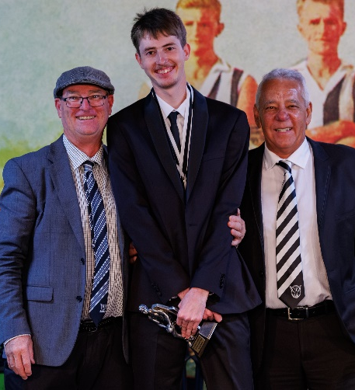
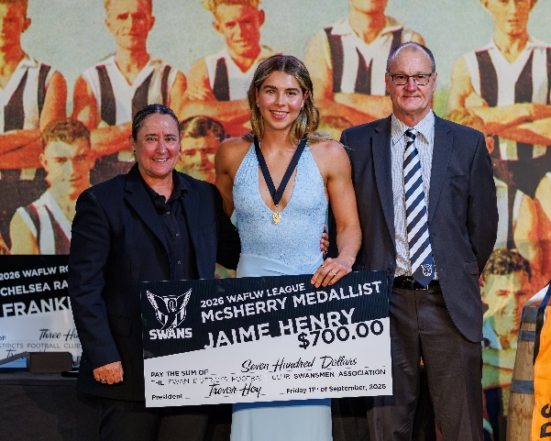
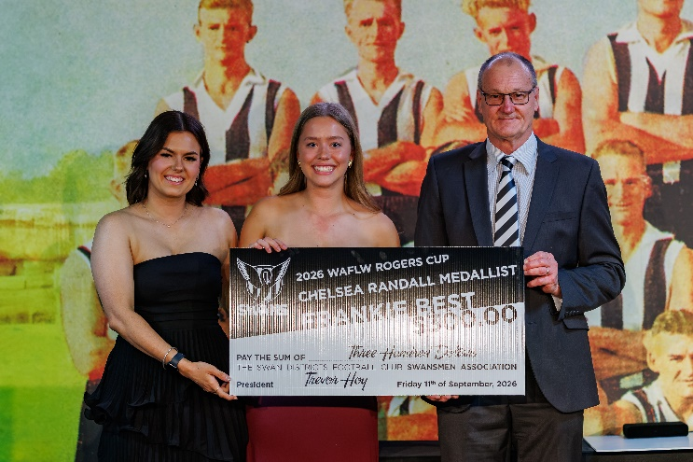
The Women's Medal night was held at the Club on Friday 11th September. A great night was had by all with the Club putting on excellent evening. The McSherry Medal for the Fairest & Best League player for 2026 went to Jaime Henry, last year’s winner. Jemma Sly was runner-up with Jess Cox third. The Colts saw Frankie Best win the Chelsea Randall Medal with Khalia Fawcett runner-up and Charli Grau third. Congratulations to all the girls on their Awards – funded by the Swansmen.
Maurice Embley Medal winner Jackson Foskett with left, Andy Holmes and right Maurice Embley
Chelsea Randall Medal winner Frankie Best with left, Rogers Cup Coach Tayah Reed and right Swansmen President Trevor Hoy
McSherry Medal winner Jaime Henry with left, Mandy McSherry and right Swansmen President Trevor Hoy
WAFLW Dhara Kerr Medal

Jaimie Henry’ accolades continued at the Sandover Medal, winning the WAFLW Dhara Kerr Medal with a record breaking 35 votes, the previous highest being 27 votes. That makes it a clean sweep for Jaime as she also won the Lou Knitter Medal for best afield in the Grand Final and romped home in the Clubs McSherry Medal, amassing a record breaking 193 votes to win by 93 votes. Congratulations to Jaime on an outstanding effort and we hope that her dream of an AFLW draft comes to fruition.
September Dinner Meeting
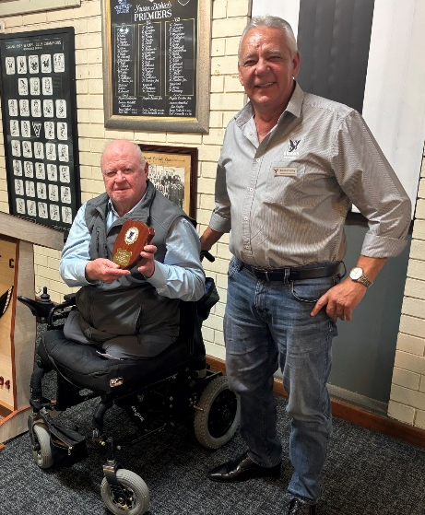
- The Guest Speaker for the night was Graham Edwards, Vietnam Vet and former Labor Politician. Graham was born in Kalgoorlie but came to Perth with his family as his dad had compromised health. As a boy, he lived in the Scarborough area. He left school at 15 years of age, and his first job was with the railways, as a ‘call boy’, waking up train crews at all hours of the night. Graham always loved sport; particularly football. He joined the army and was sent to serve in Vietnam. While there, he realised that the local Vietnamese didn’t want forces from other countries there. He concluded that the war was only going to end one way; which it did. On his return to Australia, he noted that Vietnam veterans were being shunned by the public. Approximately 500 veterans committed suicide. Graham is not sure how, but he ended up in politics, where he spent 14 years in State Parliament. He later entered Federal Parliament, where he served for 9 years. Graham was responsible for the establishment of the WA Football Commission. He is the Patron of Wheelchairs for Kids and all proceeds of his book, Stone the Bloody Crows, will go to Wheelchairs for Kids.
Graham Edwards, left after receiving his Guest Speaker Shield from Maurice Embley
- The dinner raffle was drawn by the guest speaker Graham Edwards with Peter Hodyl the lucky winner.
Thursday Night – Swans Members Night

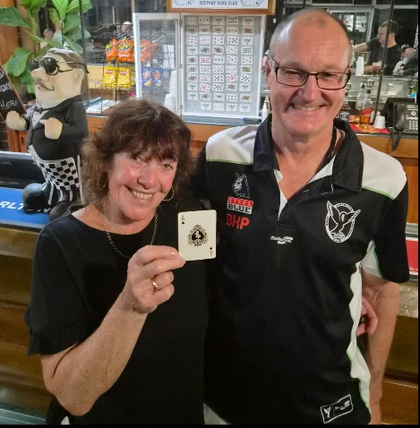
The 'Chase the Ace' jackpot of $7010 went off on Thursday 17th September. The lucky winner was the first lady Nessa Hodyl, a regular Members night attendee since its inception. Ness rang the bar bell on the night and also generously donated back $1000 to kick start the jackpot. Congratulations Nessa, deserved winner, spend it wisely.

All Club Members and Supporters are invited to Steel Blue Oval on Thursday nights to join in the following activities in the main bar:
Chase the Ace – The jackpot as of Thursday 1st October is $1,270.
Free Members Draw – The jackpot as of Thursday 1st October is $1,400. The lucky member must be in attendance and claim the prize within 2 minutes – otherwise a jackpot of $100 is added.

Fundraising for 2026

The Retravision Auction - The annual Swansmen on-line Auction was a great success again this year and ran for the entire month of August. With over 200 items up for grabs there was a chance to bag a bargain or two. Overtime bidding was in play again and continued for 30 minutes or so and added an extra $5600 plus to the total. The net result was $54,900, an outstanding effort.
I would like to thank all those suppliers and donors who contributed to the Auction, their support is greatly appreciated. I would also like to take this opportunity to thank from the Club, Jarrad Wright, Ross Leipold and Mitch Eastman, and from the Swansmen, Kim Doust, Des Hardiman and Ross Wheldon, for their efforts, and all Swansmen who contributed items or cash.

Wine Wall - tickets are now on sale. This is your opportunity to purchase a carton, 12 bottles, or more if you like, of good quality mixed red and white wines for the meagre price of $150.
Some of the wineries included are from local West Swan wineries including Garbin, Lamonts, Mandoon, Nikola, Oakover and Talijancich and from the Margaret River region Fermoy Estate, Hamelin Bay and Hay Shed. Thanks also to Liquor Wholesalers and Celebrations.
Each carton purchased will receive a ticket to go into the draw for a special bottle/bottles of something.
For further details contact Trevor Hoy or Des Hardiman.
Sponsor A Picket - This is your chance to share in a unique piece of Western Australian sporting history. The sponsored picket could be a birthday gift, memorial remembrance for a loved one, personal favourite spot, or just a tribute to the great memories over the years at Bassendean Oval. Your choice of location around the ground. Only $150.00

Coming Events

Date | Event | Time | Venue/ Guest | Guest Speaker
Tuesday 20th October | DINNER MEETING 8 | 6:30pm | Away Dinner | The Stirling Arms Hotel
Tuesday 10th November | Committee Meeting | 6:00pm | Swansmen Lounge
Tuesday 17th November | DINNER MEETING 9 | 6:30pm | PPOA Room | AGM
Sunday 13th December | Xmas Luncheon | 12:00pm | Kappy’s

Notice of AGM
In accordance with the Constitution please note that the
Annual General Meeting
of the Swansmen will be held at the November Dinner Meeting at the Club on
Tuesday 17th November 2026

All positions on the Committee will be declared vacant and those wishing to nominate are asked to notify the Secretary by Friday 13th November 2026

Next Month's Dinner (November 17th) - AGM

The November dinner is the AGM and final dinner meeting of the year.

Committee 2026

President: Trevor Hoy 0405 453 042 president.swansmen@gmail.com
Vice President: Tim Outred 0403 337 996 timbo63@live.com.au
Secretary: Kim Doust 0410 570 723 secretary.swansmen@gmail.com
Treasurer: Mark Hocking 0452 651 564 xbmcvb@gmail.com

Committee: Neville Bassett 0402 318 846 njb@westarcapital.com.au
Jim Benson 0405 713 978 jamesbensonlidholm@gmail.com
Darryl Crotty 0422 375 456 dccrotts@icloud.com
Maurice Embley 0431 663 977 maurice.embley@hotmail.com
Steve Grech 0406 167 110 steveandjulie@iinet.net.au
Des Hardiman 0448 792 832 hardiman.des@bigpond.com
Mark McNair 0481 815 647 macka66666@gmail.com
Greg Roberts 0411 417 799 gregroberts@kpfp.com.au
Jim Watterston 0403 340 500 jim.actdet@gmail.com

