Women's Football
Both the women’s sides played in the Second Semi Final and won, advancing straight into the Grand Final where they both played East Fremantle. The Rogers Cup girls were first up and East Fremantle got the jump on the young black and whites kicking 2.6 to zip in the first term. Swans composed themselves in the second term and matched the Sharks on the scoreboard kicking 1.2 to 1.1 to go into the long break 17-points down. The third quarter was another even tussle with Swans reducing the deficit at the last break to 12-points. The black and whites upped the anti in the last term kicking 2.0 to zip to level the score at the final siren and take the game into golden score extra time. Swans continued to control the run of the game and kept on attacking. Eventually it was Khalia Fawcett who received a free-kick for a push in the back deep in the forward pocket. She went back knowing that any score would win Swans the premiership and she managed to kick a behind, with the final score being 5.4 to 4.9 and giving them the first Premiership since 2017. Congratulations to the coaching staff and the players on their achievement, well done. Unfortunately, it was the opposite scenario with the League. Swans led all day going into the first break 4-points up, halftime by 2-points and three quarter-time by nine-points. But East Fremantle surged in the last quarter kicking 2.2 to 0.1, with the winning goal coming at the 18-minute mark, to win the premiership by 4-points, 3.5 to 2.7. On a bright note, Jaime Henry capped her remarkable season for Swans by winning the Lou Knitter Medal having been judged best afield in the Grand Final with 31 possessions and 13 tackles. Congratulations to the coaching staff and the players on getting into the Grand Final, well done, and better luck for 2027.

Men's Football
Rounds 18 to 20 saw the Colts win one and lose two, finishing sixth on the ladder, while the Reserves won two and lost one to finish on top of the ladder and earn a week off in the first week of the finals. They will play East Perth in the Second Semi Final. The League were in both games at the last break in round 18 against Claremont and round 19 against Perth but unfortunately couldn’t sustain the effort in the last, losing both games. The final game of the season was against East Fremantle away. With both teams on 20 points this was the battle for eighth position as well as pride. Swans jumped out of the blocks kicking 5.4 to 2.1 in the first and 3.1 to 2.5 in the second to take a 23-point lead into the long break. The third term was a goal fest with Swans kicking 6.4 to the Sharks 5.2, with the black and whites extending their lead to 31-points at the last change. East Fremantle had the better on the scoreboard in the last kicking 2.2 to 1.2 but the damage had already been done with the black ducks winning by 25-points to end the season on a winning note.

All Abilities Football
The All-Abilities played High Wycombe in the Second Semi Final at Steel Blue Oval and won, advancing straight into the Grand Final where they played High Wycombe. Swans had won their last two encounters so a win was possible. It was an even first term with Swans going into the first break 1-point up, 1.2 to 1.1. Inaccurate kicking let the black and whites down in the second quarter with five shots on goal and missing all while High Wycombe had two shots for 100% accuracy and went into the long break 6-points up, 3.1 to 1.7. High Wycombe’s ascendancy continued in the third outscoring Swans 2.1 to 1.0 to go into the last break 13-points up, 5.2 to 2.7. It was an even last term with both sides kicking 2.1 apiece and High Wycombe holding on to win by 13-points, 7.3 to 4.8. Congratulations to the coaching staff and the players on getting into the Grand Final, well done, and better luck for 2027.

Trevor Hoy (President)

SEPTEMBER DINNER MEETING
Tuesday 15th SEPTEMBER 2026 6:30pm
Past Players & Officials Room Upstairs

GUEST SPEAKER

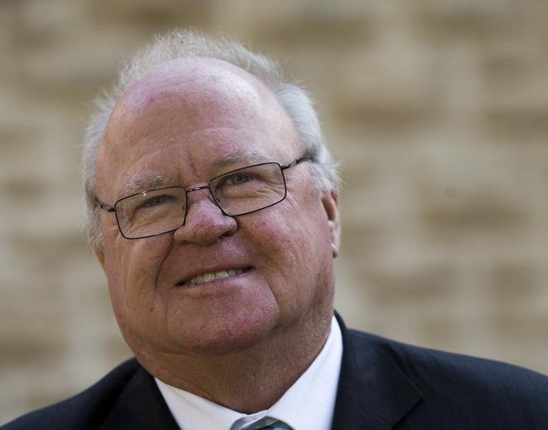
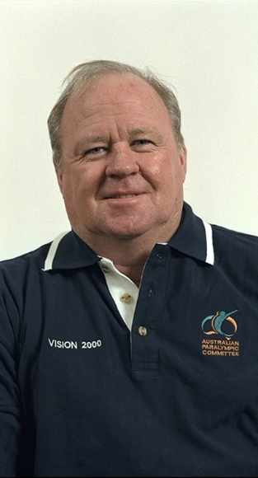
Graham Edwards – Vietnam Vet and Former Labor Politician
Graham was an Australian soldier and former Labor Party member who represented the North Metropolitan Upper House electorate in State Parliament from 1983 to 1997 and the Federal seat of Cowan in the Australian House of Representatives from 1998 to 2007, and is a veterans' advocate.

Numbers must be confirmed before Tuesday 8th September by one of the following methods:

RSVP via the online link at RSVP or phone Trevor Hoy on 0405 453 042

Please note, that if you RSVP 'Yes' to a dinner and do not attend the Swansmen still have to pay for your meal.

Invite a Guest
We ask all members to RSVP to the dinners early and we ask that you endeavour to bring along a guest so that we get good numbers and increase our profile.

August Dinner Meeting
- League player Jake Pasini gave an update on his life, both on and off the field, since he returned to Swans in 2024.
- New Victorian recruit Jez Rigoni gave an insight into his football journey and what lured him west to join Swans.
- The Guest Speaker for the night was Graeme Wood, former Australian Cricketer. Murray Reid conducted a Q&A session with Graeme mainly related to all the on and off the ground antics of his cricket career.
- The dinner raffle was won by Roy Jewel.

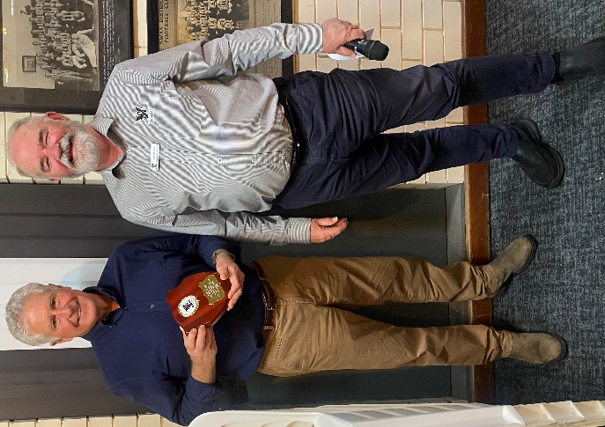
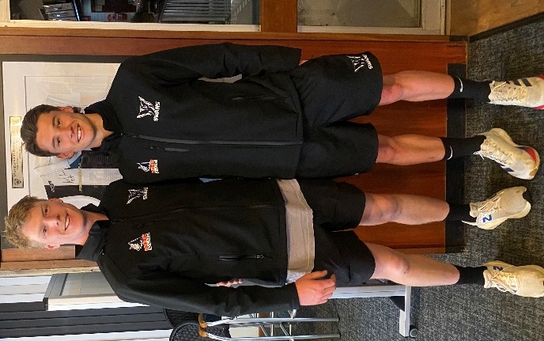
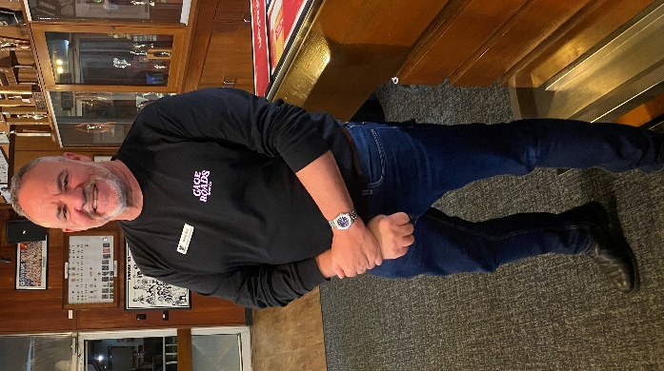

Murray Reid
Graeme Wood, left after receiving his Guest Speaker Shield from Jim Benson
Jake Pasini, left and Jez Rigoni
Thursday Night – Swans Members Night

All Club Members and Supporters are invited to Steel Blue Oval on Thursday nights to watch the team train and then join in the following activities in the main bar:
Chase the Ace – The jackpot as of Thursday 27th July is $6,345.
Free Members Draw – The jackpot as of Thursday 27th July is $1,900. The lucky member must be in attendance and claim the prize within 2 minutes – otherwise a jackpot of $100 is added.

Fundraising for 2026

The Retravision Auction - ended 7.34pm, after overtime bidding, Thursday 27th August with another excellent result. Over $89,000 was raised from successful bidders. Watch this space in the October edition for the final result with the nett result to be around $56k.

Wine Wall - tickets are now on sale. This is your opportunity to purchase a carton, 12 bottles, or more if you like, of good quality mixed red and white wines for the meagre price of $150.

Some of the wineries included are from local West Swan wineries including Kosovich, Mandoon, Nikola, Oakover, Garbin, Lamonts, Talijancich and Sittella's. Thanks also to Liquor Wholesalers and Celebrations Maida vale.

Each carton purchased will receive a ticket to go into the draw for a special bottle of wine.
For further details contact Trevor Hoy or Des Hardiman.

Sponsor A Picket - This is your chance to share in a unique piece of Western Australian sporting history. The sponsored picket could be a birthday gift, memorial remembrance for a loved one, personal favourite spot, or just a tribute to the great memories over the years at Bassendean Oval. Your choice of location around the ground. Only $150.00

From the Archives

Checkout the current or former Swansmen in this photo:
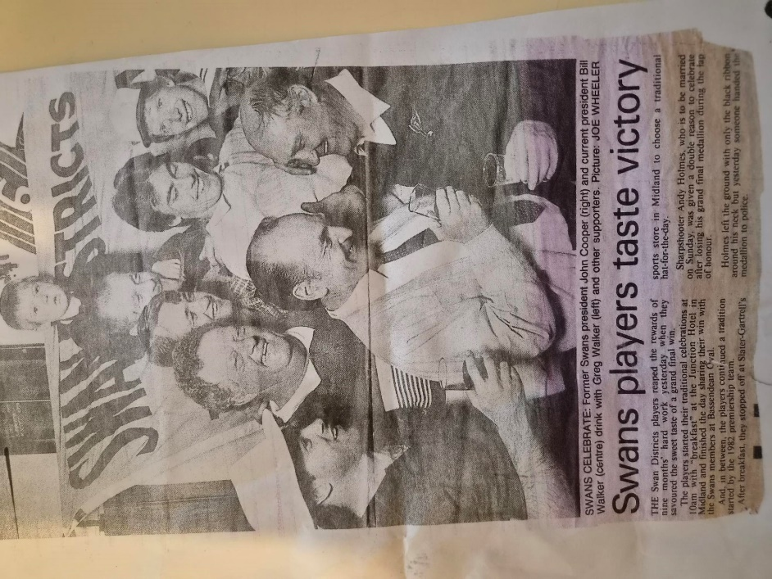

Greg Walker, Maurie Wellstead, Peter Bacon, Peter and Ben Hodyl, David Ogg, Ken Bell, Bill Walker and John Cooper.
Andy Holmes gets a mention too!

Coming Events

Date | Event | Time | Venue/ Guest | Guest Speaker
Friday 4th September | Maurice Embley Medal | 6:30pm | Presidents Suite
Friday 11th September | McSherry Medal | 6:30pm | Presidents Suite
Tuesday 15th September | DINNER MEETING 7 | 6:30pm | PPOA Room | Graham Edwards AM
Friday 2nd October | Swan Medal | 6:30pm | Mandoon
Tuesday 6th October | Committee Meeting | 6:00pm | Swansmen Lounge
Tuesday 20th October | DINNER MEETING 8 | 6:30pm | Away Dinner | TBC
Tuesday 10th November | Committee Meeting | 6:00pm | Swansmen Lounge
Tuesday 17th November | DINNER MEETING 9 | 6:30pm | PPOA Room | AGM

Committee 2026

President: Trevor Hoy 0405 453 042 president.swansmen@gmail.com
Vice President: Tim Outred 0403 337 996 timbo63@live.com.au
Secretary: Kim Doust 0410 570 723 secretary.swansmen@gmail.com
Treasurer: Mark Hocking 0452 651 564 xbmcvb@gmail.com

Committee: Neville Bassett 0402 318 846 njb@westarcapital.com.au
Steven Bakes 0477 666 775 ssbakes@bigpond.com
Jim Benson 0405 713 978 jamesbensonlidholm@gmail.com
Darryl Crotty 0422 375 456 dccrotts@icloud.com
Maurice Embley 0431 663 977 maurice.embley@hotmail.com
Steve Grech 0406 167 110 steveandjulie@iinet.net.au
Des Hardiman 0448 792 832 hardiman.des@bigpond.com
Mark McNair 0481 815 647 macka66666@gmail.com
Greg Roberts 0411 417 799 gregroberts@kpfp.com.au
Jim Watterston 0403 340 500 jim.actdet@gmail.com

