Archive Room Renovation

The Swansmen were approached by a member of the Heritage Committee requesting if a shelving unit could be installed in the archive room in the Sponsors Lounge to store all the old framed jumpers and photos clogging the Boardroom. Resident chippy Gary Cox was called upon again to utilise his many skills and come up with an appropriate design. Gary was onto this task immediately and the shelving was installed on Monday 3rd August. Many thanks Gary for once again coming to the rescue.
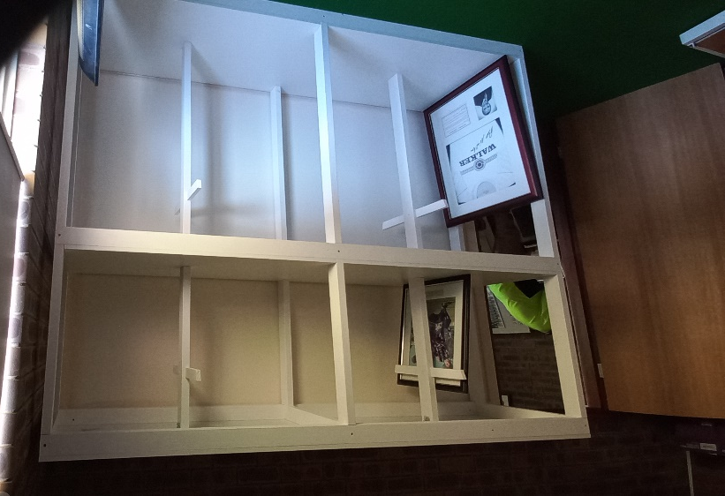
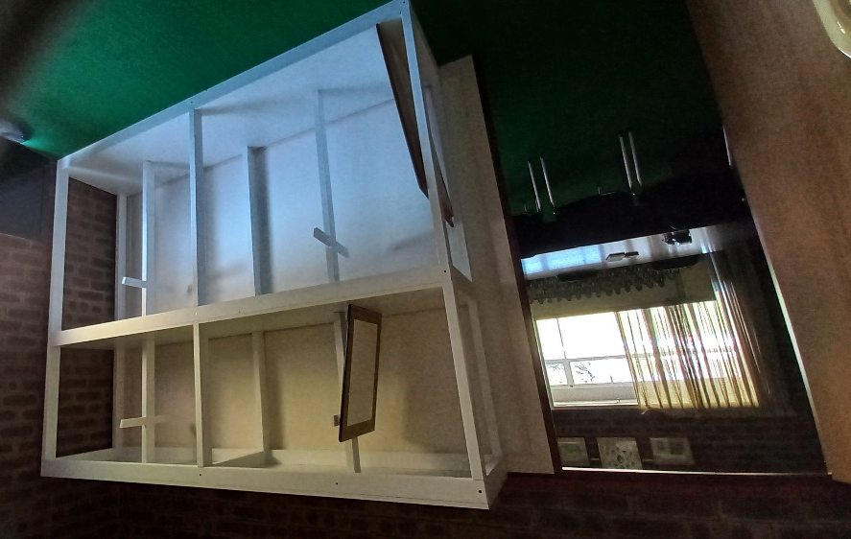

Women's Football

Both the women’s sides won their last two games of the regular season, with the Rogers Cup girls finishing second on percentage and the League girls finishing on top by a game. They will both play in the Second Semi Final at Steel Blue Oval on Sunday 9th August. We wish them all the best for their finals campaign.

Men's Football

Rounds 15 to 17 saw both the Colts and Reserves win one and lose one, round 16 was a bye. The Reserves unbeaten run ended with a 5-point loss to Peel in Round 17. They still sit top of the ladder by 3 games while the Colts are sixth, one game behind fifth.
The League were in both games at the last break in round 15 against South Fremantle and round 17 against Peel but unfortunately couldn’t sustain the effort in the last, losing both games. They remain in eighth position on percentage above East Fremantle.

All Abilities Football

The All-Abilities ended the regular season on a good note winning their last three games, which included a 19-point win over the ladder leaders. They finished on top of the ladder and earned a week off.

Trevor Hoy (President)

AUGUST DINNER MEETING
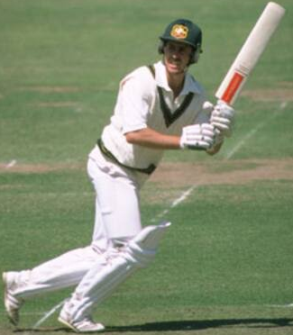
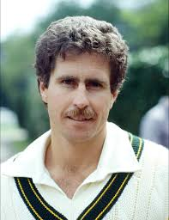
Tuesday 18TH AUGUST 2026 6:30pm
Past Players & Officials Room Upstairs

GUEST SPEAKER

Graeme Wood – Former Australian Cricketer
Graeme played 59 Test matches and 83 One Day Internationals from 1978 to 1989. He scored nine Test centuries in his career, which was a record for a Western Australian, until it was surpassed by Justin Langer.

Numbers must be confirmed before Tuesday 11th August by one of the following methods:

RSVP via the online link at RSVP or phone Trevor Hoy on 0405 453 042

Please note, that if you RSVP 'Yes' to a dinner and do not attend the Swansmen still have to pay for your meal.

Invite a Guest
We ask all members to RSVP to the dinners early and we ask that you endeavour to bring along a guest so that we get good numbers and increase our profile.

July Dinner Meeting
- No league players for the night as they were unable to attend.
- The Guest Speaker for the night was Peter Snow OAM. Peter gave a presentation into his involvement in the purchase of the former Cheyne’s Beach Whaling Station in Albany and turning it from a derelict remnant of the past into a significant tourist attraction.
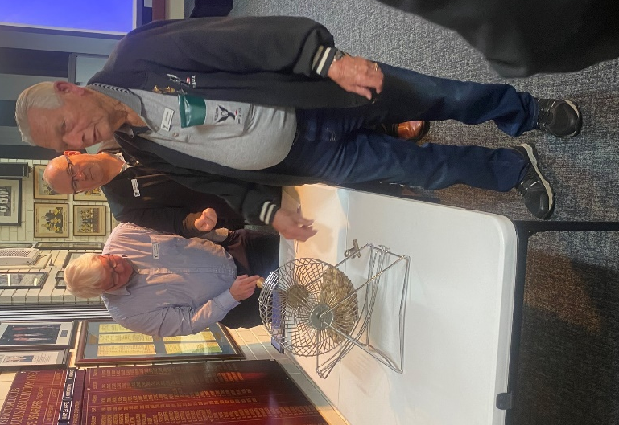
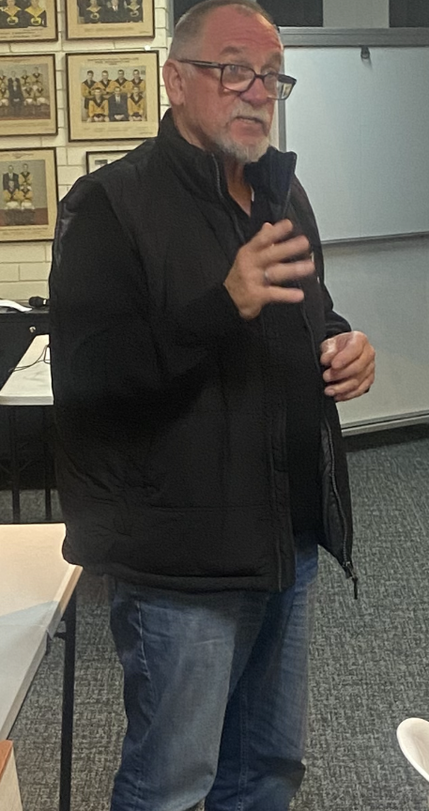
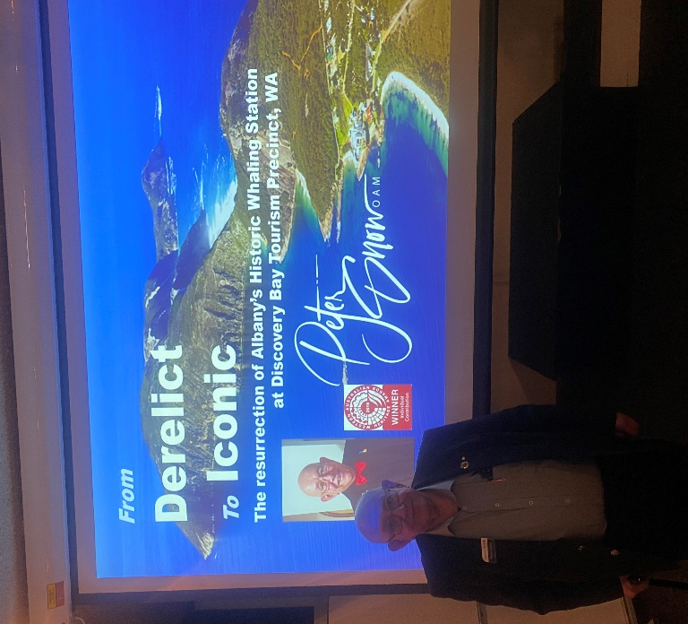
- The dinner raffle was won by Greg Roberts.
Peter Snow commencing his presentation
Club President Peter Hodyl addressing the members
Jonh Rowe conducting the AFL Raffle draw

Thursday Night – Swans Members Night

All Club Members and Supporters are invited to Steel Blue Oval on Thursday nights to watch the team train and then join in the following activities in the main bar:
Chase the Ace – The jackpot as of Thursday 30th July is $5,760.
Free Members Draw – The jackpot as of Thursday 30th July is $1,500. The lucky member must be in attendance and claim the prize within 2 minutes – otherwise a jackpot of $100 is added.

Fundraising for 2026

The Retravision Auction - The Galabid On-Line Auction is up and running. Follow the link below to register and view auction items, www.galabid.com/swans. Auction ends 7.00pm Thursday 27th August. Some items up for grabs include the following:
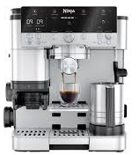
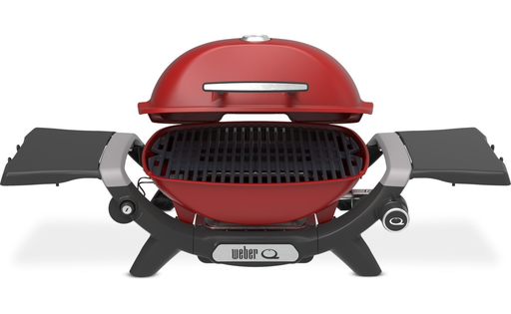
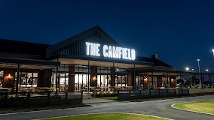

Selection of hospitality vouchers including The Camfiled and The Stables
New 2026 Ford Everest Active SUV
West Coast Eagles 8 seat Corporate Box
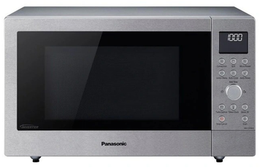


Coffee Machines
Electrical Items
Weber Baby Q1200N

AFL Grand Final/Cash Bonanza Raffle - was drawn at the July dinner meeting. Thanks to all for your support and to Paul Grimes for organising the raffle, a great effort for is maiden raffle. The results as follows:
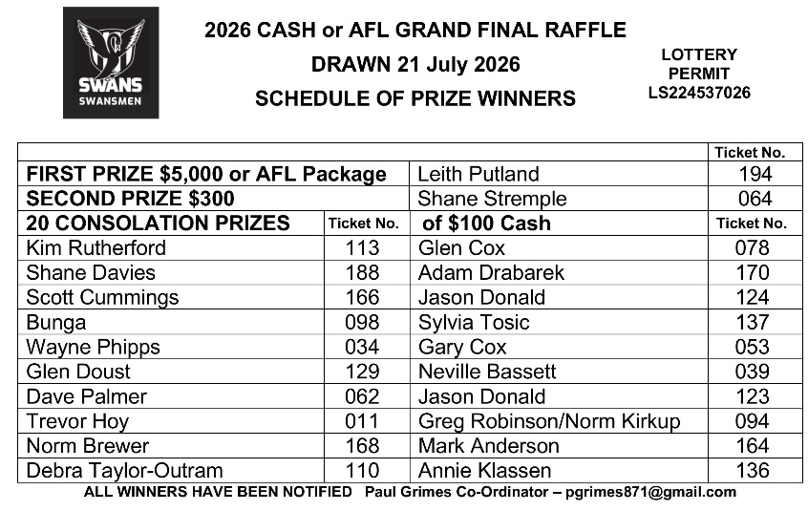
Sponsor A Picket - This is your chance to share in a unique piece of Western Australian sporting history. The sponsored picket could be a birthday gift, memorial remembrance for a loved one, personal favourite spot, or just a tribute to the great memories over the years at Bassendean Oval. Your choice of location around the ground. Only $150.00

Coming Events
Date | Event | Time | Venue/ Guest | Guest Speaker
Tuesday 18th August | DINNER MEETING 6 | 6:30pm | PPOA Room | Graeme Wood
Friday 11th September | McSherry Medal | 6:30pm | Presidents Suite | TBC
Tuesday 15th September | DINNER MEETING 7 | 6:30pm | PPOA Room | Graham Edwards AM
Friday 3rd October | Swan Medal | 6:30pm | Mandoon | TBC
Tuesday 6th October | Committee Meeting | 6:00pm | Swansmen Lounge
Tuesday 20th October | DINNER MEETING 8 | 6:30pm | Away Dinner | TBC
Tuesday 10th November | Committee Meeting | 6:00pm | Swansmen Lounge
Tuesday 17th November | DINNER MEETING 9 | 6:30pm | PPOA Room | AGM

Committee 2026

President: Trevor Hoy 0405 453 042 president.swansmen@gmail.com
Vice President: Tim Outred 0403 337 996 timbo63@live.com.au
Secretary: Kim Doust 0410 570 723 secretary.swansmen@gmail.com
Treasurer: Mark Hocking 0452 651 564 xbmcvb@gmail.com

Committee: Neville Bassett 0402 318 846 njb@westarcapital.com.au
Steven Bakes 0477 666 775 ssbakes@bigpond.com
Jim Benson 0405 713 978 jamesbensonlidholm@gmail.com
Darryl Crotty 0422 375 456 dccrotts@icloud.com
Maurice Embley 0431 663 977 maurice.embley@hotmail.com
Steve Grech 0406 167 110 steveandjulie@iinet.net.au
Des Hardiman 0448 792 832 hardiman.des@bigpond.com
Mark McNair 0481 815 647 macka66666@gmail.com
Greg Roberts 0411 417 799 gregroberts@kpfp.com.au
Jim Watterston 0403 340 500 jim.actdet@gmail.com

