Women's Football
After consecutive losses in Round 8 and 9 the Rogers Cup girls have won six games in a row and sit one game clear on top of the ladder after Round 15.
Rounds 10 to 15 have seen the League girls win 5, lose 1. The wins included thumping Peel by 90 points in Round 10 and South Fremantle by 69 points in Round 12. The loss was to Subiaco by 5 points at Steel Blue in Round 13, errant kicking let the side down, 3.8 to 5.1. They sit on top of the ladder by percentage from Claremont.

Men's Football
Rounds 9 to 14 have not been easy for the Colts, only winning one out of the 4 games, a one point come from behind thriller over East Perth in Round 14. Reserves players been promoted to the injury ravaged League side due to injury means that Colts players are promoted to the Reserves side leaving the coaching staff having to call on their younger stock to fill the voids. The win has catapulted them into fifth spot on the ladder, with only percentage separating them from eight spot in what is a tight competition.
The Reserves unbeaten run continued, although they were tested against West Perth in Round 13, 5-point win and East Perth in Round 14, 14-point win. It is a remarkable effort considering the changes to the side due to injuries to the League team. They sit top of the ladder by 4 games.
The League’s toppsie turvey season continues. After an impressive win over Perth in Round 8, they faced a full-strength AFL listed Peel Thunder at Mandurah in Round 9, a game to forget. Round 10 was back at Steel Blue against the Eagles. In what was a spiteful first half, Swans went into the main break 3-points up. Errant kicking in the third term, 0.6 to 3.3 saw the Eagles in front by two goals at the last change. Although Swans won the last quarter, 3.2 to 2.3, it was not enough to overcome the deficit, going down by 7-points making it two losses in a row to the Eagles. Round 11 was a bye. Round 12 was away to Subiaco. It was a close game all day with Swans going into the long break 2-points up, 4.4 to 4.2. Subiaco got the ascendancy on the scoreboard in the third kicking 3.1 to 2.2 and go into the last break 3-points up. The last term was a tight battle, going down to the wire, but in the end Subiaco prevailed kicking 2.3 to 2.2 and win by 4-points. Round 13 saw Swans head to Joondalup to front up to West Perth. Although West Perth had only on one win for the season, they are always a challenge at home. After an even first quarter, 3.5 to 3.2, Swans opened the game up in the second kicking 5.1 to 0.5 and go into the long break 29-points up. The second half was an even affair and even though West Perth outscored Swans 6.5 to 5.7 the Black Ducks took the win by 24-points. Round 14 was back at home to East Perth. The Royals were coming off a 51-point thrashing of Perth and had top five aspirations in their sites. Swans came to play and after a tight first term they opened the game up in the second with a 7.1 to 2.2 quarter and go into the long break 3 goals up. Errant kicking by the Royals in the third term, 2.4 to 1.1, kept Swans in the game and the Black Ducks took full advantage in the last kicking 3.6 to 2.2 and take an unlikely win by 19-points. They move into eighth position on percentage above East Fremantle.

All Abilities Football
Rounds 6 to 10 has seen the All-Abilities side win 5 straight, including an impressive 33-point win over second place University away in Round 10. Round 11 was a bye. The win has seen them move into second place on the ladder, percentage from University, with a game in hand.

Trevor Hoy (President)

JULY DINNER MEETING
Tuesday 21st JULY 2026 6:30pm
Past Players & Officials Room Upstairs

GUEST SPEAKER

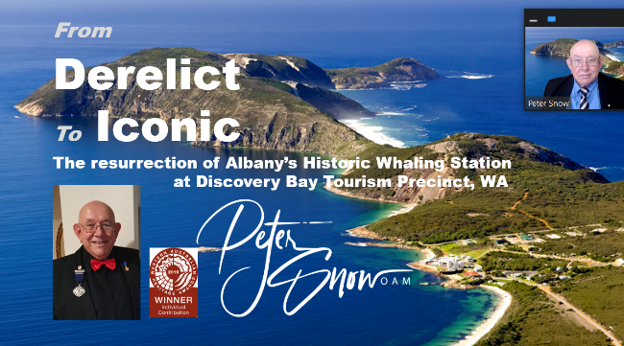
Peter Snow OAM – Derelict to Iconic: Turning Vision into Reality
Peter will give a fascinating presentation revealing how a chance conversation in a Gold Coast bar sparked the transformation of a crumbling industrial site into a multi-award-winning destination that has contributed more than $40 million to Albany's economy.
Supported by powerful before-and-after imagery—including the innovative transformation of abandoned whale oil tanks and degraded bushland—this is an inspiring story of vision, persistence and seeing opportunity where others saw only decay.

Numbers must be confirmed before Tuesday 14th July by one of the following methods:

RSVP via the online link at RSVP or phone Trevor Hoy on 0405 453 042

Please note, that if you RSVP 'Yes' to a dinner and do not attend the Swansmen still have to pay for your meal.

Invite a Guest
We ask all members to RSVP to the dinners early and we ask that you endeavour to bring along a guest so that we get good numbers and increase our profile.

Membership Drive
A reminder for those who have not renewed their membership to please do so. An email was sent out in February. Subscriptions have remained at $35 and can be paid by any of the following methods:

- Pay at the Club Office (together with your Club Membership) and add the Swansmen membership
- Pay online via the Club webpage
- Pay at the June Dinner Meeting
- Pay direct to the Swansmen bank account, BSB: 036-080 A/C: 276254, include your name.

June Dinner Meeting
- League player Seb Bright gave an insight into his football journey thus far and what brought him to Swans.
- New Victorian recruit Lucas Impey gave an insight into his football journey and what lured him west to join Swans.
- The Guest Speaker for the night was Hayden Cobley, Swans WAFL Talent Manager. He spoke about being a local lad growing up in the Swan Valley playing cricket and football and similar employment roles at East Perth and Sydney Swans prior to joining Swans. He gave an insight into what the WAFL Talent Manager position involved and the amount of time took up.
- The dinner raffle was won by Neville Bassett.

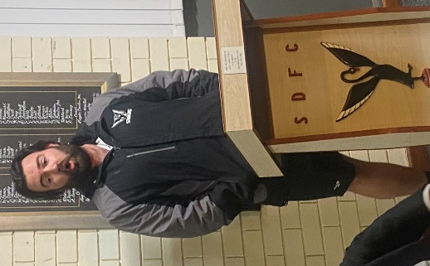
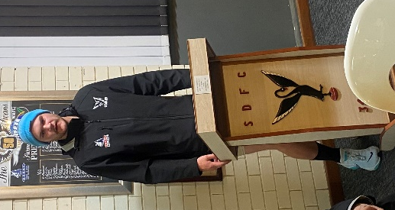
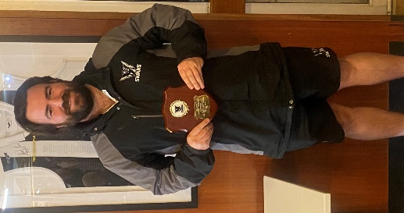
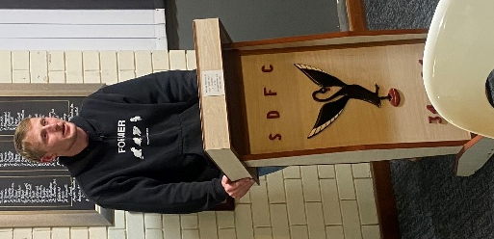

Lucas Impey addressing the members
Seb Bright addressing the members
Hayden Cobley with his Guest Speaker shield
Hayden Cobley addressing the members

Thursday Night – Swans Members Night

The 'Members Draw' jackpot has gone off twice in the last month. League Captain Jesse Turner took off the jackpot of $2000 on Thursday 11th June and regular Thursday night attendee Scotty Hooson took off the jackpot of $1100 on Thursday 25th June. Congratulations to both.

All Club Members and Supporters are invited to Steel Blue Oval on Thursday nights to watch the team train and then join in the following activities in the main bar:
Chase the Ace – The jackpot as of Thursday 9th July is $5,260.
Free Members Draw – The jackpot as of Thursday 9th July is $1,200. The lucky member must be in attendance and claim the prize within 2 minutes – otherwise a jackpot of $100 is added.

Fundraising for 2026

The retraVision Swansmen Auction – WE NEED YOUR HELP AND DONATIONS
On-line event only again. Will run the entirety of August. The Club is on board again to make this the big fundraiser for the season. The Auction site should be up and running mid-July.
Watch this space, the Club website and your inbox for further details.

3 ways YOU can help make the Auction a HUGE success and add to our donation to the Club at year end:

1. Drop into a known business or restaurant near you and ask for a donation to the auction by way of a product or voucher.
2. Seek a wine maker or donate a carton of wine for the wine wall.
3. Donate $20, $50 or $100 to our ‘retraVision’ pool of funds for us to purchase additional home products for the auction catalogue.



AFL Grand Final/Cash Bonanza Raffle - Tickets sold out. The winner will be drawn at the July dinner.

Sponsor A Picket - This is your chance to share in a unique piece of Western Australian sporting history. The sponsored picket could be a birthday gift, memorial remembrance for a loved one, personal favourite spot, or just a tribute to the great memories over the years at Bassendean Oval. Your choice of location around the ground. Only $150.00

Coming Events
Date | Event | Time | Venue/ Guest | Guest Speaker
Tuesday 21st July | DINNER MEETING 5 | 6:30pm | PPOA Room | Peter Snow OAM
Saturday 1st August | On-line Auction | 12:00am | www.galabid.com/swans
Tuesday 4th August | Committee Meeting | 6:00pm | Swansmen Lounge
Tuesday 18th August | DINNER MEETING 6 | 6:30pm | PPOA Room | Graeme Wood
Friday 11th September | McSherry Medal | 6:30pm | Presidents Suite | TBC
Tuesday 15th September | DINNER MEETING 7 | 6:30pm | PPOA Room | Graham Edwards AM

Committee 2026

President: Trevor Hoy 0405 453 042 president.swansmen@gmail.com
Vice President: Tim Outred 0403 337 996 timbo63@live.com.au
Secretary: Kim Doust 0410 570 723 secretary.swansmen@gmail.com
Treasurer: Mark Hocking 0452 651 564 xbmcvb@gmail.com

Committee: Neville Bassett 0402 318 846 njb@westarcapital.com.au
Steven Bakes 0477 666 775 ssbakes@bigpond.com
Jim Benson 0405 713 978 jamesbensonlidholm@gmail.com
Darryl Crotty 0422 375 456 dccrotts@icloud.com
Maurice Embley 0431 663 977 maurice.embley@hotmail.com
Steve Grech 0406 167 110 steveandjulie@iinet.net.au
Des Hardiman 0448 792 832 hardiman.des@bigpond.com
Mark McNair 0481 815 647 macka66666@gmail.com
Greg Roberts 0411 417 799 gregroberts@kpfp.com.au
Jim Watterston 0403 340 500 jim.actdet@gmail.com

