Women's Football

The unbeaten run of the women’s sides came to an end in Round 8 against Claremont. In both games the Tigers dominated after quarter time, which led to the first loss of the season for both Swans teams. Round 9 was a Friday night clash against Subiaco at Sullivan Logistic Stadium. After an even first quarter in the Rogers Cup, Subiaco dominated the next three to inflict the young Swans their second loss in a row. They now sit third on the ladder, percentage behind Subiaco.
The League girls had a gutsy hard-fought 4-point win. In what was a close game all day, Swans went into the last break 1 point down, 3.4 to 2.9, inaccurate kicking not helping the scoreline. In a tight last term, both sides had two scoring shots apiece, with Swans making the better of their opportunities kicking 2.0 to 1.1 to get back on the winners list. They now sit top of the ladder.

Men's Football

After four straight losses, the Colts finally got on the board in Round 6 with a big win over second placed East Fremantle at Steel Blue Oval. After an even first term Swans opened the game up in the second kicking 6.2 to 2.3 to take a 21-point lead into the long break. Inaccurate kicking in the third term, 2.7 to 2.2, didn’t reflect the dominance of the young Swans in the term with the three-quarter time lead only increasing by 5 points. The final term was a replica of the second with Swans dominating, and getting their kicking boots back on, outscoring the opposition 5.2 to 3.1 and get a 39-point win. They continued their good form into Round 7 with a thumping 75-point win over Subiaco and followed that up with a 51-point win over Perth in Round 8 making it three wins on the trot and catapulting them into fourth spot on the ladder.
The Reserves unbeaten run continued, although they were tested against Claremont in Round 5, 22-point win and Subiaco in Round 7, 7 goals to one last term to post a 46-point win. Round 6 was the standout with a thumping 117-point win over East Fremantle. They sit top of the ladder.
The League’s toppsie turvey season continues. A loss to Claremont away in Round 5 was followed up by a stirring 42-point win over East Fremantle at home in Round 6 and then a disappointing loss to Subiaco at home in Round 7. Round 8 was a season defining game against Perth at home, lose and stay entrenched at second bottom, win and keep in touch with the five. Perth dominated the first half on the ground but not on the scoreboard kicking 5.2 to 0.2 in the first term and 2.5 to 1.2 in the second to take a 39-point lead into the long break. The move of Jackson McLachlan onto Brandan Parfitt was a master stroke, cutting his influence on the game while Swans intensity lifted, dominating the term and outscoring Perth 2.4 to 1.1, going into the last break 5 goals down. In what must be the greatest comeback in Swans modern history, the team lifted and kicked 7 goals to zip in the last quarter to clinch an unlikely 11-point win, extraordinary. They move into seventh position and keep their top five aspirations alive.

All Abilities Football

After two straight wins Swans have suffered two straight losses, University away in Round 3 and High Wycombe at Steel Blue Oval in Round 5. Round 4 was a bye. They currently sit fourth on the ladder.

Trevor Hoy (President)

JUNE DINNER MEETING
Tuesday 16th JUNE 2026 6:30pm
Past Players & Officials Room Upstairs

GUEST SPEAKER

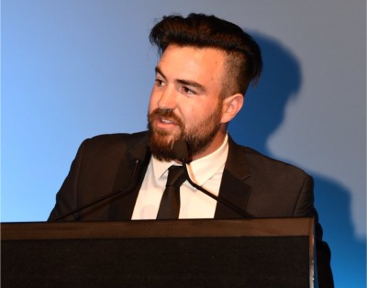
Hayden Cobley – Swans WAFL Talent Manager
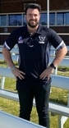
Hayden Cobley took over the role from Greg Harding in 2022. The role oversees all aspects of the Swans WAFL talent program and is an important conduit between the talent and senior football programs. Prior to this he was involved in the Club’s Development Squad programs.

Numbers must be confirmed before Tuesday 9th June by one of the following methods:

RSVP via the online link at RSVP or phone Trevor Hoy on 0405 453 042

Please note, that if you RSVP 'Yes' to a dinner and do not attend the Swansmen still have to pay for your meal.

Invite a Guest
We ask all members to RSVP to the dinners early and we ask that you endeavour to bring along a guest so that we get good numbers and increase our profile.

Membership Drive
A reminder for those who have not renewed their membership to please do so. An email was sent out in February. Subscriptions have remained at $35 and can be paid by any of the following methods:

- Pay at the Club Office (together with your Club Membership) and add the Swansmen membership
- Pay online via the Club webpage
- Pay at the June Dinner Meeting
- Pay direct to the Swansmen bank account, BSB: 036-080 A/C: 276254, include your name.

May Dinner Meeting
- The combined Swansmen dinner and Club Sponsors and Judda Bee Networking night was held at Mandoon Estate on Wednesday 13th May. Over 50 guests enjoyed good food, good drinks, good company and excellent guest speakers.
- The formalities commenced with Andy Holmes hosting Q&A sessions with representatives from the following Club Sponsors - Tim Millroy, Head of Community & Partnerships at WARRRL (Containers for Change) and James Hillgrove, partner at JBC Corporate and player sponsor of WAFL player Anthony Stephens and WAFLW player Kaitlin Allen.
- The Guest Speaker for the night was the newly appointed CEO of WA Football Brad Wira. Club CEO Jarrad Wright hosted a Q&A with Brad, with topics including leadership, governance, financial discipline and the future of football in Western Australia, drawing on his experience across WAFL football, the AFL, private wealth advisory and WA Football.
- Thanks to Lucy-Claire McMinn, Mitch Eastman, Gerry Roelofs and Ross Leipold for organising a great night.

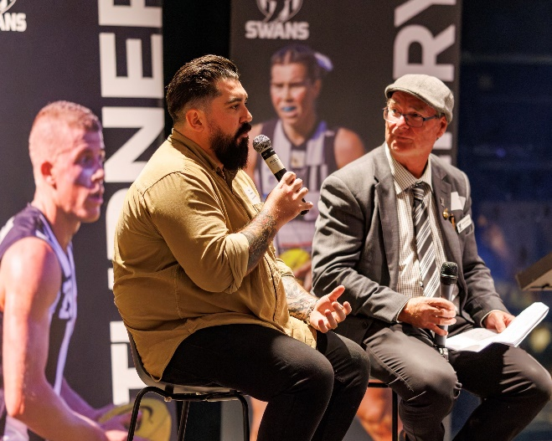
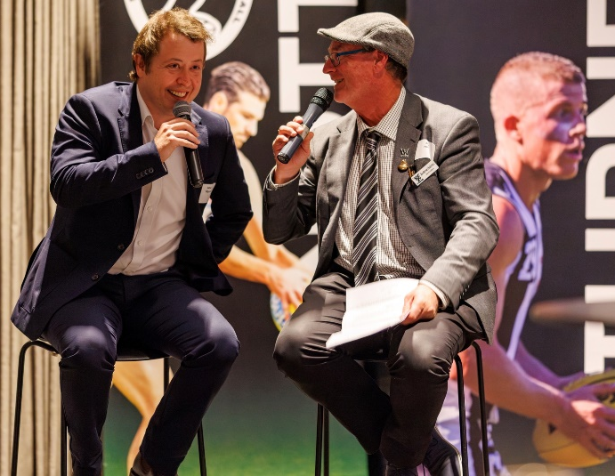
Left - Tim Millroy and Andy Holmes

Right - James Hillgrove and Andy Holmes
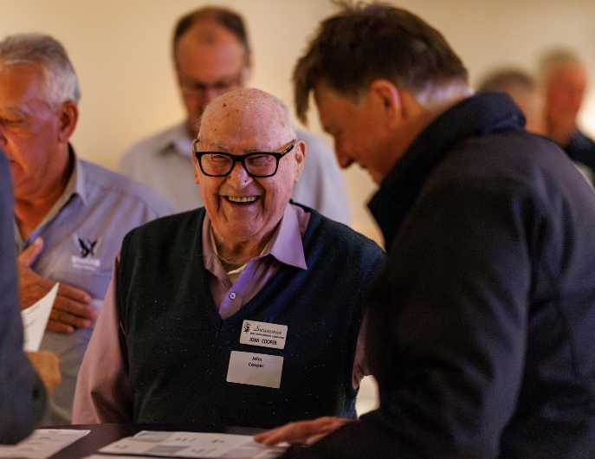
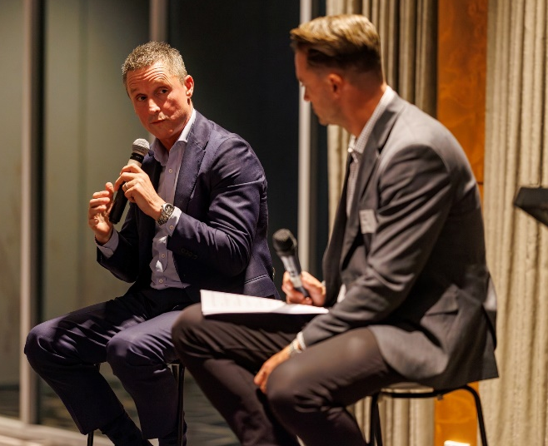
Right – John Cooper and Darryl Crotty having a good old chin wag
Left – Brad Wira and Jarrad Wright

Thursday Night – Swans Members Night

All Club Members and Supporters are invited to Steel Blue Oval on Thursday nights to watch the team train and then join in the following activities in the main bar:
Chase the Ace – The jackpot as of Thursday 28th May is $4,345.
Free Members Draw – The jackpot as of Thursday 28th May is $2,000. The lucky member must be in attendance and claim the prize within 2 minutes – otherwise a jackpot of $100 is added.

Fundraising for 2026

The retraVision Swansmen Auction – WE NEED YOUR HELP AND DONATIONS
On-line event only again. Will run the entirety of August. The Club is on board again to make this the big fundraiser for the season. The Auction site should be up and running mid-July.
Watch this space, the Club website and your inbox for further details.

3 ways YOU can help make the Auction a HUGE success and add to our donation to the Club at year end:

1. Drop into a known business or restaurant near you and ask for a donation to the auction by way of a product or voucher.
2. Seek a wine maker or donate a carton of wine for the wine wall.

3. Donate $20, $50 or $100 to our ‘retraVision’ pool of funds for us to purchase additional home products for the auction catalogue.
AFL Grand Final/Cash Bonanza Raffle - Tickets nearly sold out. The winner will be drawn at the July dinner. Price is $100 each and will be restricted to just 200. Major prize is the choice of a return trip for 2 to the 2026 AFL Grand Final or $5000 cash. There will also be a second prize of $300 plus 20 consolation prizes of your money back. See Paul Grimes or Committee for tickets.

Sponsor A Picket - This is your chance to share in a unique piece of Western Australian sporting history. The sponsored picket could be a birthday gift, memorial remembrance for a loved one, personal favourite spot, or just a tribute to the great memories over the years at Bassendean Oval. Your choice of location around the ground. Only $150.00

Coming Events
Date | Event | Time | Venue/ Guest | Guest Speaker
Tuesday 2nd June | Committee Meeting | 6:00pm | Swansmen Lounge
Tuesday 16th June | DINNER MEETING 4 | 6:30pm | PPOA Room | Hayden Cobley
Tuesday 21st July | DINNER MEETING 5 | 6:30pm | PPOA Room | Graeme Edwards
Saturday 1st August | On-line Auction | 12:00am | www.galabid.com/swans
Tuesday 4th August | Committee Meeting | 6:00pm | Swansmen Lounge
Tuesday 18th August | DINNER MEETING 6 | 6:30pm | PPOA Room | Graeme Wood

Committee 2026

President: Trevor Hoy 0405 453 042 president.swansmen@gmail.com
Vice President: Tim Outred 0403 337 996 timbo63@live.com.au
Secretary: Kim Doust 0410 570 723 secretary.swansmen@gmail.com
Treasurer: Mark Hocking 0452 651 564 xbmcvb@gmail.com

Committee: Neville Bassett 0402 318 846 njb@westarcapital.com.au
Steven Bakes 0477 666 775 ssbakes@bigpond.com
Jim Benson 0405 713 978 jamesbensonlidholm@gmail.com
Darryl Crotty 0422 375 456 dccrotts@icloud.com
Maurice Embley 0431 663 977 maurice.embley@hotmail.com
Steve Grech 0406 167 110 steveandjulie@iinet.net.au
Des Hardiman 0448 792 832 hardiman.des@bigpond.com
Mark McNair 0481 815 647 macka66666@gmail.com
Greg Roberts 0411 417 799 gregroberts@kpfp.com.au
Jim Watterston 0403 340 500 jim.actdet@gmail.com

