Men’s Players Auditorium Renovation

The final touches have been completed in the men’s player auditorium with the graphics installed. Two walls feature over 125 images from the Clubs eight premierships and the back wall has some inspirational messages for the players. Ascot Signs have done a great job in producing and installing the graphics, with a big thanks to Des Hardiman for the concept and sourcing the individual newspaper clippings, budgets and photos. Together with the room renovations by Gary Cox, Trevor Hoy and Scott Howard in February - another great Swansmen project.
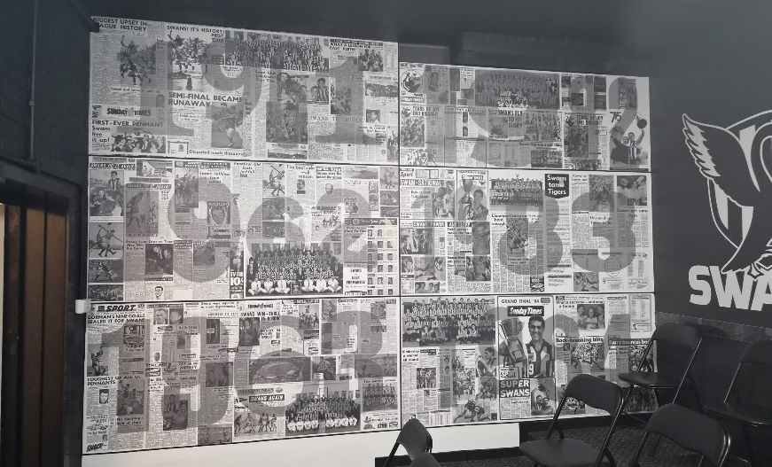
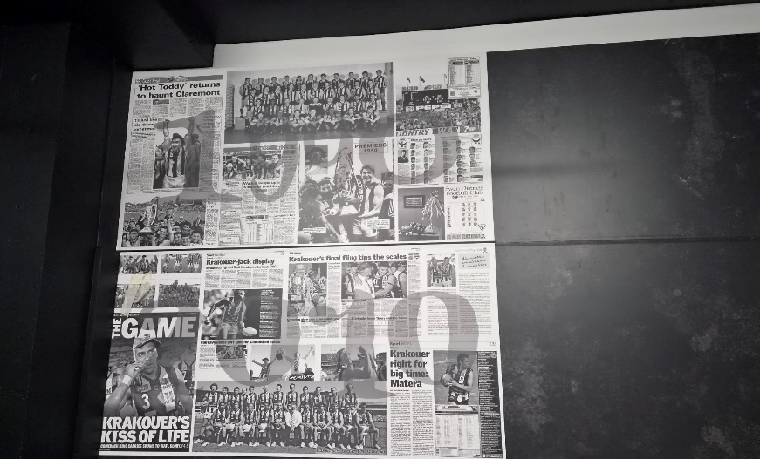
Football Front
West wall
East wall
Women's Football
Both the women’s sides have continued on their winning way and after Round 6 have not dropped a game yet. They both sit at the top of the ladder going into the bye in Round 7.
We congratulate Jaime Henry and Lauren Quaife for been selected in the Women’s State squad to play SA at Sullivan Logistics Stadium on Saturday 16th May.
Men's Football
The same can’t be said of the men’s sides. After Round 4 the Colts are yet to register a win and the League have only won one game. Their record of being the only League side that hadn’t lost to the Eagles was broken in Round 4 with a one-point loss. The shing light is the Reserves, who haven’t dropped a game yet.
We congratulate Jesse Turner and Jiah Reidy for been selected in the Men’s State squad to play SA at Sullivan Logistics Stadium on Saturday 16th May.
All Abilities Football
The All-Abilities season kicked off on Saturday 25th April with Swans playing a home game at Steel Blue Oval against Warnbro. It was a great start to the season with the team bringing home a win, 10.7 to 5.5. Round 2 was away to Wembley with the winning form continuing, 8.8 to 4.2, making it two from two.

Trevor Hoy (President)

MAY DINNER MEETING
Wednesday 13th MAY 2026 6:30pm
This is a combined Swansmen Dinner and SDFC Sponsors and Judda Bee Networking Event to be held at Mandoon Estate in the Swan Valley. The cost will be $55 per head and includes food and drinks. The Club have subsidised the Swansmen $25 per head. As this is a combined Swansmen/SDFC event partners are welcome. Guest costs are $80 for SDFC members and $90 for non-members.
This is a great opportunity to get to know the Club sponsors as well as Judda Bee members.

GUEST SPEAKER

Brad Wira – Former AFL Player and New WAFL CEO

Numbers must be confirmed before Wednesday 6th May by one of the following methods:

RSVP via the online link at RSVP or phone Trevor Hoy on 0405 453 042

As this is a combined Club event payment via EFT to the Swansmen bank account would be preferable. Swansmen bank account details are, BSB: 036-080 A/C: 276254, include your name and event.

Invite a Guest
We ask all members to RSVP to the dinners early and we ask that you endeavour to bring along a guest so that we get good numbers and increase our profile.

Membership Drive
A reminder for those who have not renewed their membership to please do so. An email was sent out in February. Subscriptions have remained at $35 and can be paid by any of the following methods:

- Pay at the Club Office (together with your Club Membership) and add the Swansmen membership
- Pay online via the Club webpage
- Pay at the April Dinner Meeting
- Pay direct to the Swansmen bank account, BSB: 036-080 A/C: 276254, include your name.

April Dinner Meeting
- League player Zane Trew gave an insight into his football journey thus far and what brought him back to Swans after his AFL stint with the Eagles.
- The Guest Speaker for the night was Ed Blackaby, 1980’s league player. Interviewer extraordinaire Ross Fitzgerald fired the mainly football career questions to Ed who answered very candidly and added a few ‘locker room only’ tales. Of course, the questions came thick and fast from the members after the interview was complete.
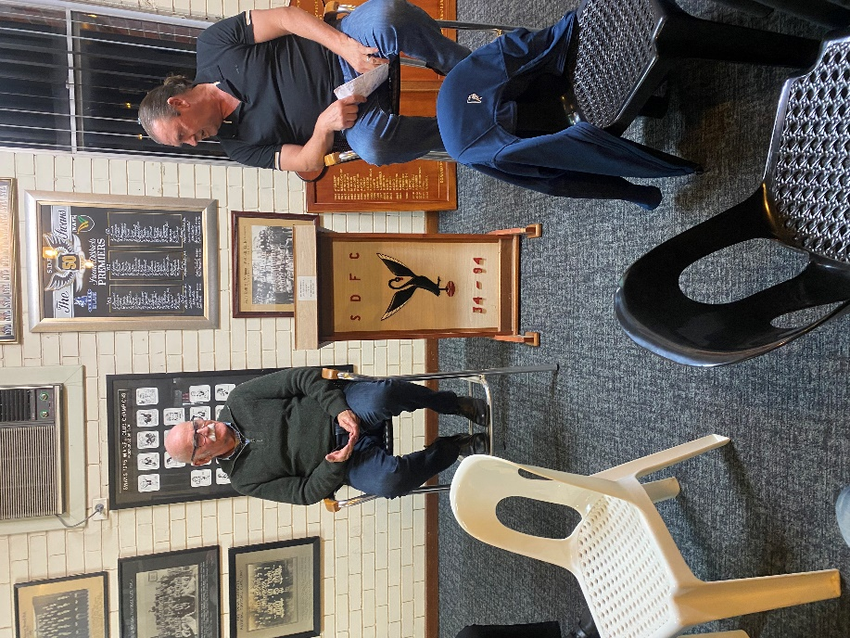
- The dinner raffle was drawn by Ed Blackaby with Darryl Crotty taking out the prize.
Left - Ed Blackaby with his Guest Speaker Shield and John Cooper game day ball

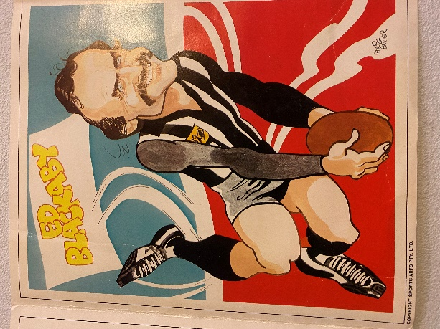
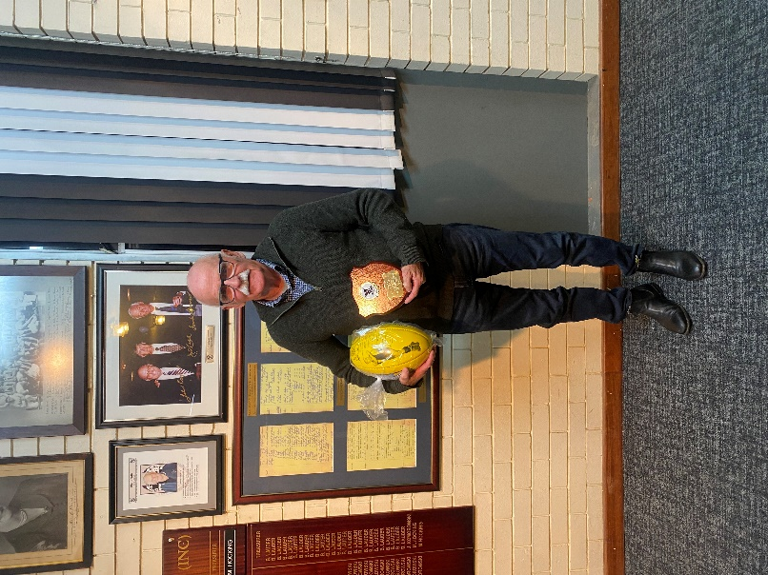

Right - Caricature of Ed Blackaby from the archives
Ross Fitzgerald firing off the questions to Ed Blackaby

Thursday Night – Swans Members Night

All Club Members and Supporters are invited to Steel Blue Oval on Thursday nights to watch the team train and then join in the following activities in the main bar:
Chase the Ace – The jackpot as of Thursday 30th April is $3,630.
Free Members Draw – The jackpot as of Thursday 30th April is $1,600. The lucky member must be in attendance and claim the prize within 2 minutes – otherwise a jackpot of $100 is added.

Fundraising for 2026

The retraVision Swansmen Auction – WE NEED YOUR HELP AND DONATIONS
On-line event only again. Will run the entirety of August. The Club is on board again to make this the big fundraiser for the season. The Auction site should be up and running mid-July.
Watch this space, the Club website and your inbox for further details.

3 ways YOU can help make the Auction a HUGE success and add to our donation to the Club at year end:

1. Drop into a known business or restaurant near you and ask for a donation to the auction by way of a product or voucher.
2. Seek a wine maker or donate a carton of wine for the wine wall.

3. Donate $20, $50 or $100 to our ‘Good Guys’ pool of funds for us to purchase additional home products for the auction catalogue.

AFL Grand Final/Cash Bonanza Raffle - Tickets on sale now. The winner will be drawn at the July dinner. Price is $100 each and will be restricted to just 200. Major prize is the choice of a return trip for 2 to the 2026 AFL Grand Final or $5000 cash. There will also be a second prize of $300 plus 20 consolation prizes of your money back. See Paul Grimes or Committee for tickets.

Sponsor A Picket - This is your chance to share in a unique piece of Western Australian sporting history. The sponsored picket could be a birthday gift, memorial remembrance for a loved one, personal favourite spot, or just a tribute to the great memories over the years at Bassendean Oval. Your choice of location around the ground. Only $150.00

Men’s Players Auditorium Renovation Photos

BEFORE GRAPHICS INSTALLED:
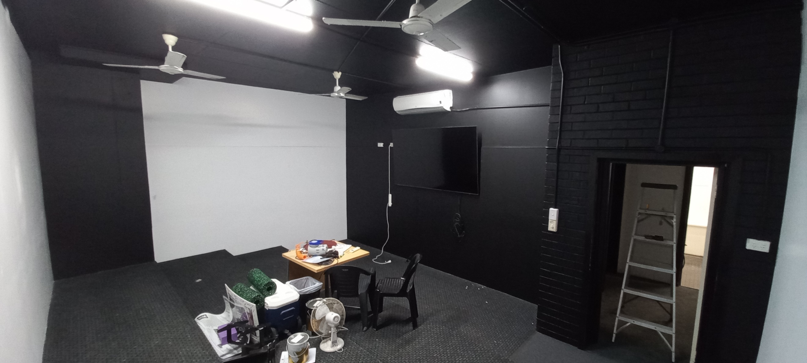
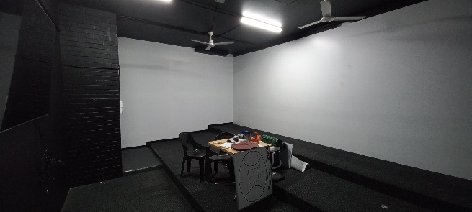

West and North walls
East and South walls

Coming Events
Date | Event | Time | Venue/ Guest | Guest Speaker
Wednesday 13th May | DINNER MEETING 3 | 6:30pm | Mandoon Estate | TBC
Tuesday 2nd June | Committee Meeting | 6:00pm | Swansmen Lounge
Tuesday 16th June | DINNER MEETING 4 | 6:30pm | PPOA Room | TBC
Tuesday 21st July | DINNER MEETING 5 | 6:30pm | PPOA Room | TBC

Committee 2026

President: Trevor Hoy 0405 453 042 president.swansmen@gmail.com
Vice President: Tim Outred 0403 337 996 timbo63@live.com.au
Secretary: Kim Doust 0410 570 723 secretary.swansmen@gmail.com
Treasurer: Mark Hocking 0452 651 564 xbmcvb@gmail.com

Committee: Neville Bassett 0402 318 846 njb@westarcapital.com.au
Steven Bakes 0477 666 775 ssbakes@bigpond.com
Jim Benson 0405 713 978 jamesbensonlidholm@gmail.com
Darryl Crotty 0422 375 456 dccrotts@icloud.com
Maurice Embley 0431 663 977 maurice.embley@hotmail.com
Steve Grech 0406 167 110 steveandjulie@iinet.net.au
Des Hardiman 0448 792 832 hardiman.des@bigpond.com
Mark McNair 0481 815 647 macka66666@gmail.com
Greg Roberts 0411 417 799 gregroberts@kpfp.com.au
Jim Watterston 0403 340 500 jim.actdet@gmail.com

