Swansmen Lounge Busy Bee

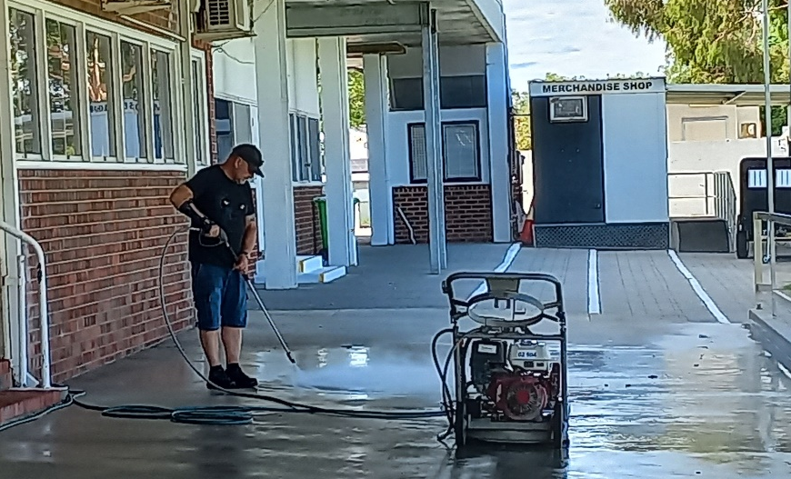
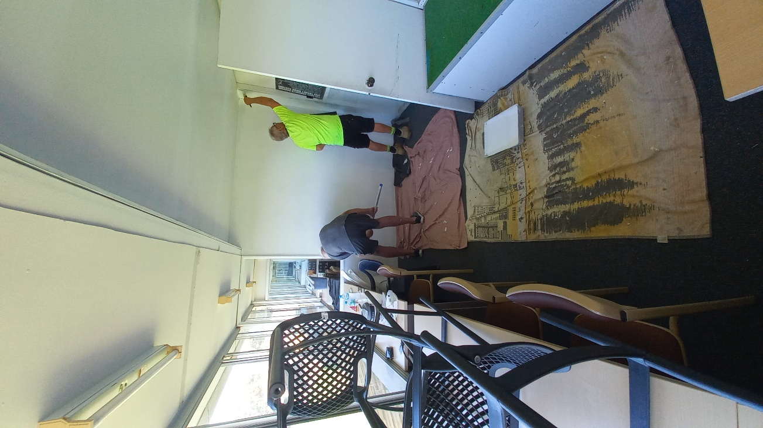
The annual Swansmen Lounge busy bee was held on Sunday 22nd March. Due to the windows being cleaned by the professionals when the Sponsors Lounge windows will be cleaned the only thing to do was to clean up the bar area, put the 2026 name tags on the honour board, place the 2025 contribution cheque on the wall next to the bar area and hang a few pictures from the picture rails along the back wall. The carpet and seats were vacuumed, the odd cobweb removed and a general cleanup in and around the Lounge. The concrete hardstand from the players changeroom to the start of the paving in front of the Can Bar was high pressured cleaned and cobwebs removed from the lights under the balcony. Pete Hodyl and his trusty TA’s Marc Hocking and Ted Martin installed three redundant aluminium seats from the Swan Bar on the hill to under the Sponsors signs on top of the hill on the Guildford side of the scoreboard. The newly renovated Coaches Box was given a lick of paint by Gary Cox and Robin McVee. The morning ended with the mandatory sausage sizzle and coldie. A big thanks to Pete Bacon, Gary Cox, Rod Greene, Paul Grimes, Des Hardiman, Marc Hocking, Pete Hodyl, Trevor Hoy, Norm Kirkup, Ted Martin, Robin McVee, Tim Outred, John Rowe and Ross Wheldon for their hard work. A big thanks to Marc Hocking for cooking the BBQ.
Right - Gary Cox and Robin McVee hard at it painting the coach’s box
Left – Tim Outred toiling away on the high-pressure cleaner
Refer to page 4 for more photos.
Football Front

Both of the girls’ sides have started the year on a high winning the first two games of the season, Claremont in Round 1 and South Fremantle in Round 2. The Rogers Cup girls played Claremont under lights on the Thursday night and after an even first half the young Swans pulled away in the second half keeping Claremont to just 2 points while kicking 3.1 to take the points 7.1 to 3.5. They continued their good form into Round 2, getting the upper hand in the first quarter and then dominate the rest of the game, winning 10.7 to 4.5. The league girls took revenge for the 2025 grand final loss against Claremont winning by 41 points, 7.9 to 1.4. They followed it up with a 48-point win over South Fremantle, 10.5 to 2.5.
Round 1 of the men’s saw Swans take on South Fremantle on Good Friday at home. The Reserves were up first and after a slow start got back into the game after half time to come away 21-point winners, 9.12 to 5.15, although, had South’s kicked straight early the result could have been different. The League was up next. Facing the reigning Premiers in Round 1 was always going to be a hard task and although they were only 5 points down at half time they couldn’t keep up with the intensity of South’s, going down by 45 points, 16.12 to 9.9. The Colts played under lights but after an even first half South’s pulled away in the second half winning by 29 points, 14.11 to 10.6.

Trevor Hoy (President)

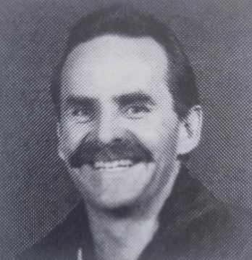
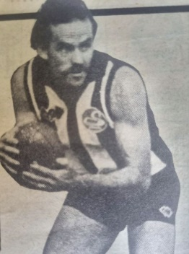
APRIL DINNER MEETING
Tuesday 21st APRIL 2026 6:30pm
Past Players & Officials Room Upstairs

GUEST SPEAKER

Ed Blackaby – What Could have been…

Despite only playing 54 games and kicking 108 goals during a 5-year career between 1980 and 1984 at Swans, Ed Blackaby was an outstanding player and only severe injury and illness prevented him from being a multi premiership player under John Todd. He came across to Perth from Manuka in Canberra at age 27, where he had played 185 games and was a local hero. A bout of glandular fever and hepatitis in 1980 saw doctors say he would not play again, but he returned to action in 1981, only to suffer further injury to cut his career short. He also coached Swans for two seasons in 1988 and 89 being credited with his input into the 1990 Premiership when John Todd was re-appointed.

We look forward to all members enjoying some good company and a good meal at our second meeting. Why not bring a guest along?

Numbers must be confirmed before Tuesday 14th April by one of the following methods:

RSVP via the online link at RSVP or phone Trevor Hoy on 0405 453 042

DUE TO A COST INCREASE BY THE CLUB, THE PRICE OF DINNERS HAS HAD TO GO UP TO $35 FOR MEMBERS AND $40 FOR NON-MEMBERS

Please note, that if you RSVP 'Yes' to a dinner and do not attend the Swansmen still have to pay for your meal.

Invite a Guest

We ask all members to RSVP to the dinners early and we ask that you endeavour to bring along a guest so that we get good numbers and increase our profile.

Membership Drive

A reminder for those who have not renewed their membership to please do so. An email was sent out in February. Subscriptions have remained at $35 and can be paid by any of the following methods:

- Pay at the Club Office (together with your Club Membership) and add the Swansmen membership
- Pay online via the Club webpage
- Pay at the April Dinner Meeting
- Pay direct to the Swansmen bank account, BSB: 036-080 A/C: 276254, include your name.

March Dinner Meeting

- Both the Men’s, Andrew Pruyn, and Women’s, Jason Burton, League coaches took time out to give a run down on where their respective league squads were at and their expectations for the year ahead with both coaches naming the new recruits for 2026. The women are taking the 1-point loss to Claremont in last year’s grand final as motivation to go one step further this year. The men are hoping to improve on the 2025 season. Overall, both groups are confident and excited to get the year running, they just want the season proper to start.
- The dinner raffle was won by Ross Fitzgerald.

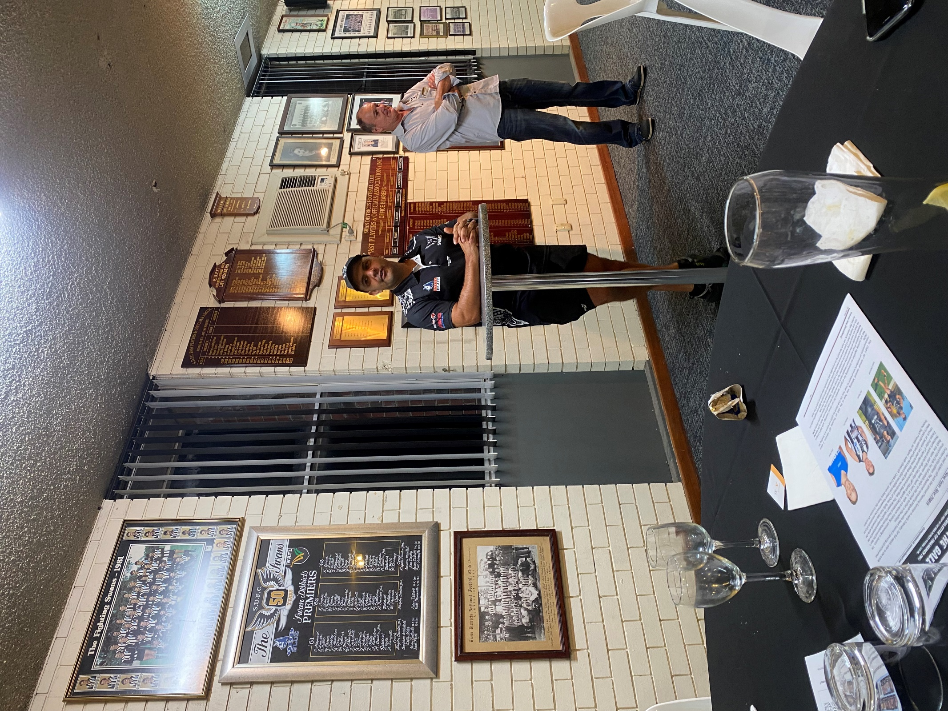
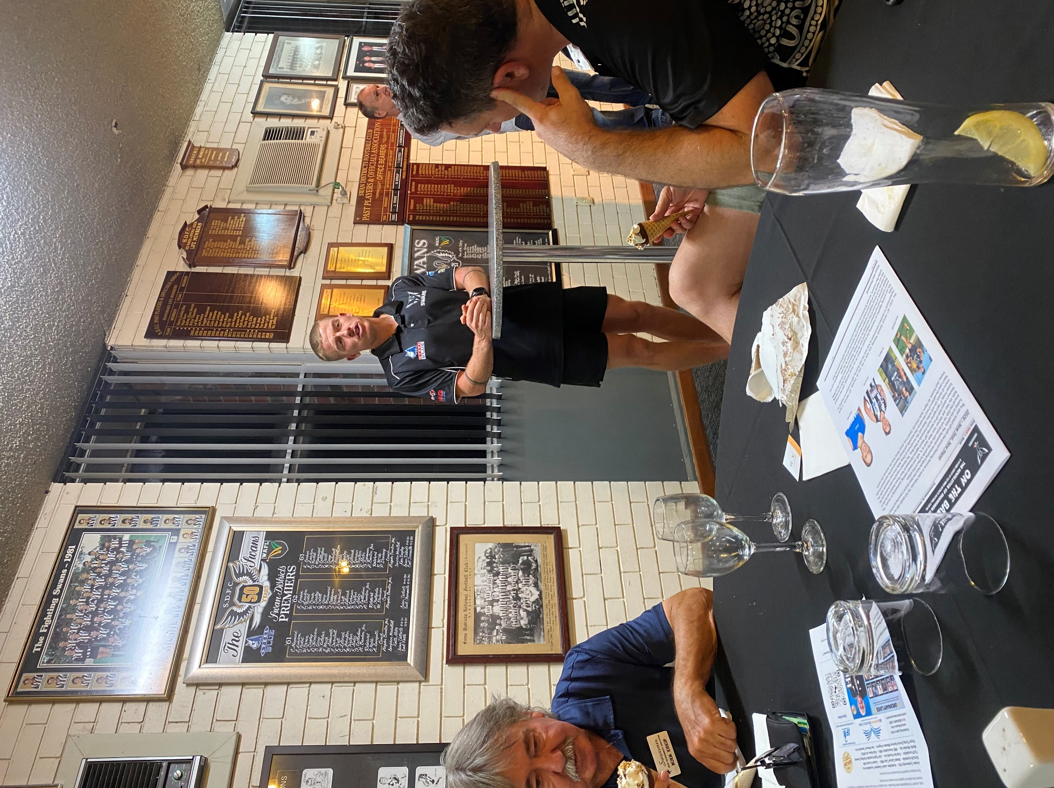
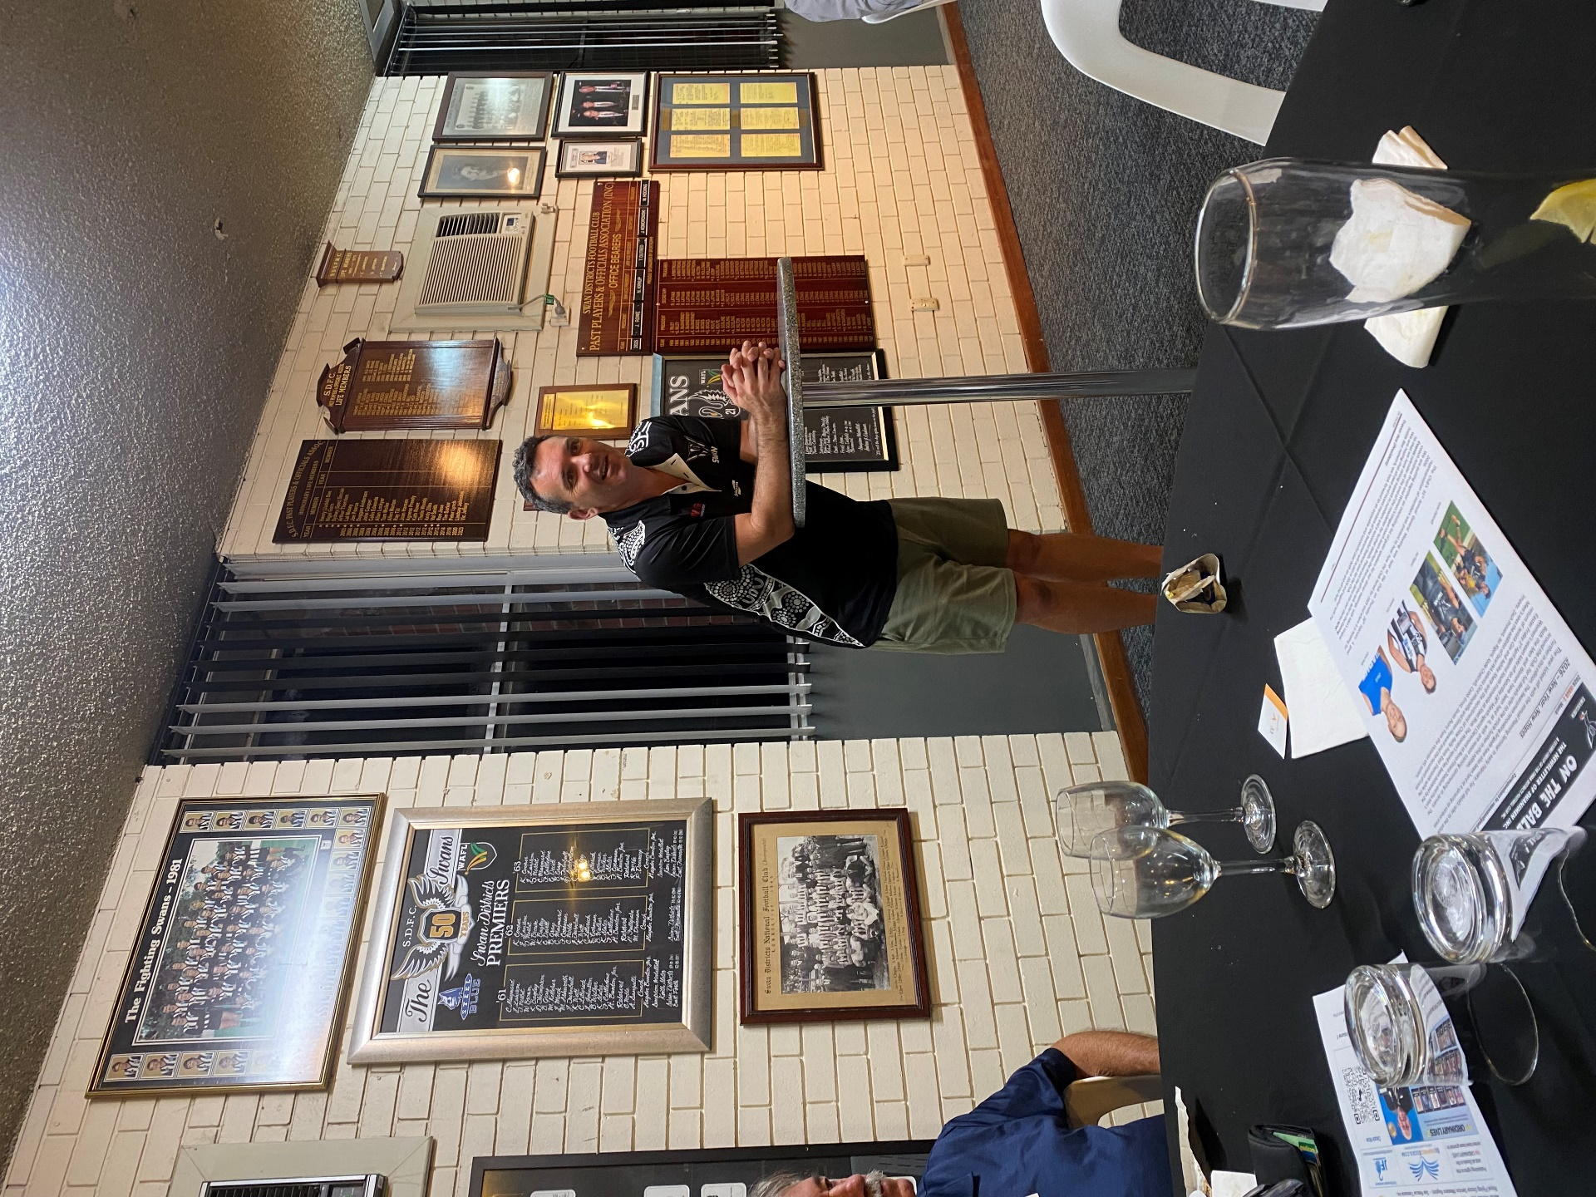

Men’s League Coach Andrew Pruyn addressing the members
Women’s League Coach Jason Burton addressing the members
Men’s League Captain Jesse Turner addressing the members

Thursday Night – Swans Members Night

All Club Members and Supporters are invited to Steel Blue Oval on Thursday nights to watch the team train and then join in the following activities in the main bar:
Chase the Ace – The jackpot as of Thursday 9th April is $3,245.
Free Members Draw – The jackpot as of Thursday 9th April is $1,300. The lucky member must be in attendance and claim the prize within 2 minutes – otherwise a jackpot of $100 is added.

Fundraising for 2026

AFL Grand Final/Cash Bonanza Raffle - Tickets on sale now. The winner will be drawn at the July dinner. Price is $100 each and will be restricted to just 200. Major prize is the choice of a return trip for 2 to the 2026 AFL Grand Final or $5000 cash. There will also be a second prize of $300 plus 20 consolation prizes of your money back. See Paul Grimes or Committee for tickets.

Sponsor A Picket - This is your chance to share in a unique piece of Western Australian sporting history. The sponsored picket could be a birthday gift, memorial remembrance for a loved one, personal favourite spot, or just a tribute to the great memories over the years at Bassendean Oval. Your choice of location around the ground. Only $150.00

Coming Events
Date | Event | Time | Venue/ Guest | Guest Speaker
Tuesday 21st April | DINNER MEETING 2 | 6:30pm | PPOA Room | Ed Blackaby
Wednesday 13th May | DINNER MEETING 3 | 6:30pm | Mandoon Estate | TBC
Tuesday 2nd June | Committee Meeting | 6:00pm | Swansmen Lounge
Tuesday 16th June | DINNER MEETING 4 | 6:30pm | PPOA Room | TBC
Tuesday 21st July | DINNER MEETING 5 | 6:30pm | PPOA Room | TBC

Committee 2026

President: Trevor Hoy 0405 453 042 president.swansmen@gmail.com
Vice President: Tim Outred 0403 337 996 timbo63@live.com.au
Secretary: Kim Doust 0410 570 723 secretary.swansmen@gmail.com
Treasurer: Mark Hocking 0452 651 564 xbmcvb@gmail.com

Committee: Neville Bassett 0402 318 846 njb@westarcapital.com.au
Steven Bakes 0477 666 775 ssbakes@bigpond.com
Jim Benson 0405 713 978 jamesbensonlidholm@gmail.com
Darryl Crotty 0422 375 456 dccrotts@icloud.com
Maurice Embley 0431 663 977 maurice.embley@hotmail.com
Steve Grech 0406 167 110 steveandjulie@iinet.net.au
Des Hardiman 0448 792 832 hardiman.des@bigpond.com
Mark McNair 0481 815 647 macka66666@gmail.com
Greg Roberts 0411 417 799 gregroberts@kpfp.com.au
Jim Watterston 0403 340 500 jim.actdet@gmail.com

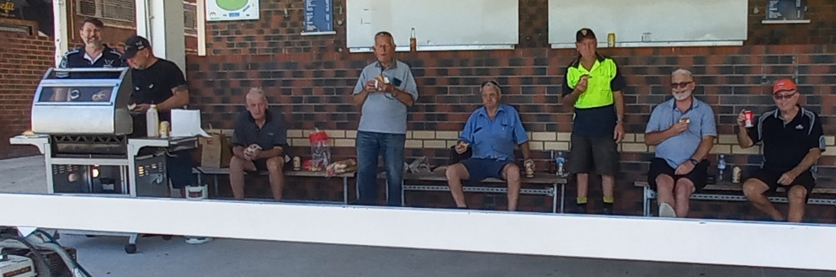
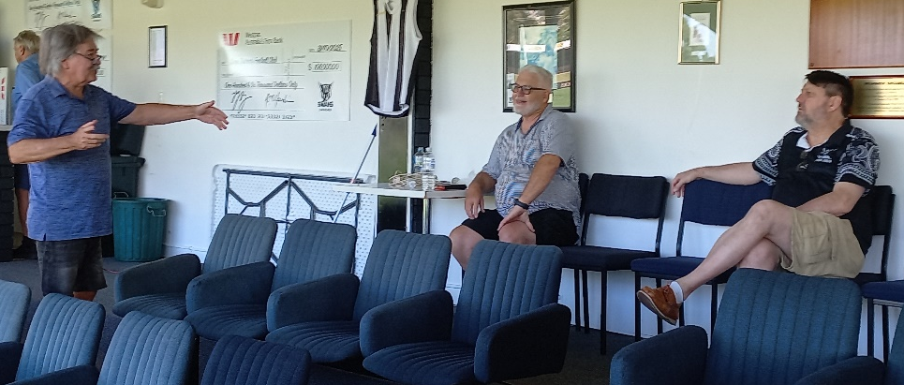
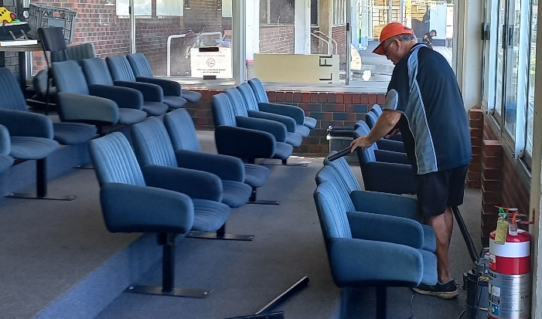
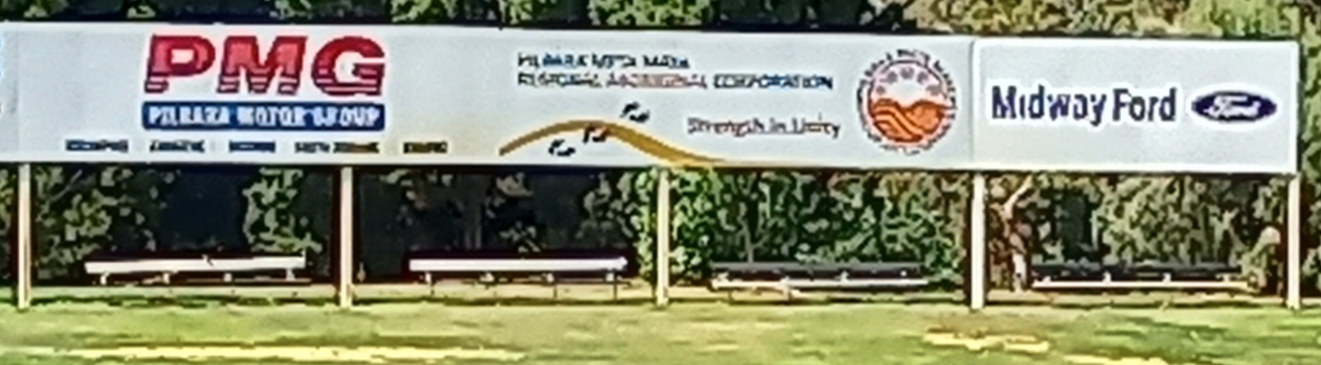
Swansmen Lounge Busy Bee
The workers enjoying a hot sausage sizzle and a coldie after their hard mornings work. From Left: Marc Hocking, Tim Outred, Robin McVee, John Rowe, Pete Bacon, Ted Martin, Ross Wheldon and Rod Greene
(Absent – Gary Cox, Des Hardiman, Pete Hodyl and Norm Kirkup) Photographer – Trevor Hoy
Rod Greene giving the vacuum cleaner a workout
Norm Kirkup, Ross Wheldon and Marc Hocking solving the problems of the world
The installed bench seats on the northeast hill

