2026 – New Year, New Hopes

The year kicked off with the annual Planning Seminar in early February. For full details refer to the article further in this edition. The Swansmen renovating brigade have also been hard at it sprucing up various areas around the Club. For full details refer to the article further in this edition.
Both the Men and Women have been hard at it, with pre-season training commencing in January. The Women’s season kicks off on Saturday 28th March against Claremont at Revo Fitness Stadium and the Men’s Easter Friday 3rd April against South Fremantle at Steel Blue. The Women’s squad has been bolstered by the return of Jessica Cox and Ashley Sharp and the recruitment of Chloe Reilly from East Fremantle while the Men’s sees the addition of local WA talents Clint Hinchliffe and Simon Hayward and the recruitment of Lucas Impey, Zach Provest, Jez Rigoni, Kade Chalcraft, Caleb Ernst, Jovan Petric from the Victorian VFL system.

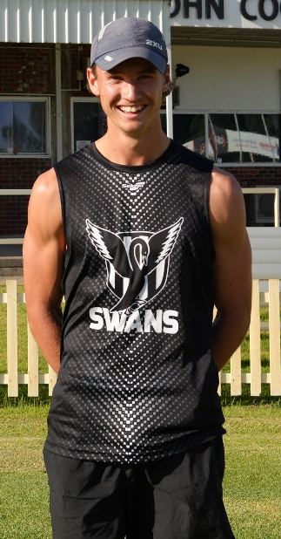

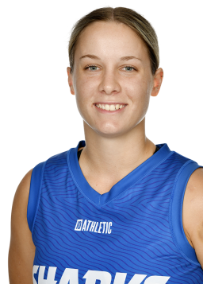
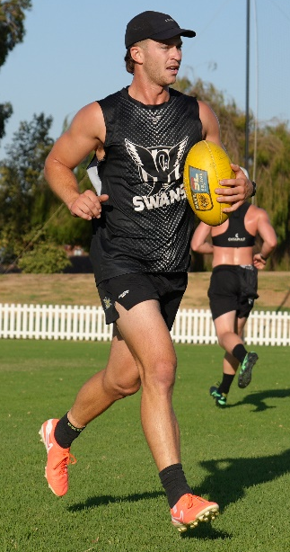

Kade Chalcraft
Jez Rigoni
Jessica Cox
Chloe Reilly

The Club's 91st Annual General Meeting was held at the Club on Thursday 26th February. A good representation of members was present to hear how the Club faired for 2025 and where it is heading for 2026.
We are putting together an interesting list of guest speakers for our dinner meetings, with Men’s League coach Andrew Pruyn and Women’s League coach Jason Burton the first cab off the rank. Refer to the Coming Events calendar at the end of the newsletter for further details. Please put the dates into your diaries NOW so that we have strong support in numbers and a successful financial year for the Club.
We are hoping that all past and recent members of the Swansmen will re-join in 2026 and together with the Judda Bee network, we look forward to an enjoyable and successful year both on and off the field.

Trevor Hoy (President)

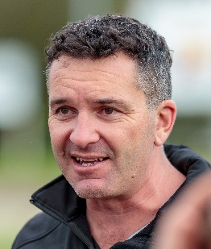
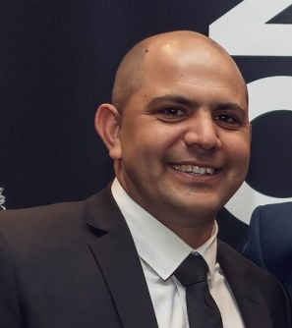
MARCH DINNER MEETING
Tuesday 17th MARCH 2026 6:30pm
Presidents Suite Upstairs

GUEST SPEAKERS

Andrew Pruyn – Men’s League Coach
Jason Burton – Women’s League Coach

Andrew and Jason will give a rundown on the form of their respective squads over the summer and their expectations of the competition this year. What will be their assessments after the pre-season games?

We look forward to all members enjoying some good company and a good meal at our first meeting. Why not bring a guest along?

Numbers must be confirmed before Tuesday 10th March by one of the following methods:

RSVP via the online link at RSVP or phone Trevor Hoy on 0405 453 042

DUE TO A COST INCREASE BY THE CLUB, THE PRICE OF DINNERS HAS HAD TO GO UP TO $35 FOR MEMBERS AND $40 FOR NON-MEMBERS

Please note, that if you RSVP 'Yes' to a dinner and do not attend the Swansmen still have to pay for your meal.

Invite a Guest

We ask all members to RSVP to the dinners early and we ask that you endeavour to bring along a guest so that we get good numbers and increase our profile.

Membership Drive

A reminder for those who have not renewed their membership to please do so. An email was sent out in February. Subscriptions have remained at $35 and can be paid by any of the following methods:

- Pay at the Club Office (together with your Club Membership) and add the Swansmen membership
- Pay online via the Club webpage
- Pay at the first Dinner Meeting
- Pay direct to the Swansmen bank account, BSB: 036-080 A/C: 276254, include your name.

Annual SWANSMEN Planning Seminar
Sunday 22nd February saw a good attendance at the Planning Seminar which was held at Kim Doust' place in Ellenbrook. 17 members were present as well as the Clubs new CEO Jarrad Wright and Operations Manager Ross Leipold. It was once again a very productive afternoon.
Operations Manager Ross Leipold gave a Club Operations update. He highlighted the major dates for the year and stated that there had been several new Club sponsors come on board. He also noted that the individual player sponsorships were gaining traction.
Club CEO Jarrad Wright gave an update of the Clubs affairs. He reinforced the Club values and the importance of engaging our community to remain relevant and sustainable. He gave an update on the Oval Redevelopment and the 2026-2028 Strategic Plan. He added that the Club would again be focussing on improving the facilities using the Swansmen 2025 contribution money.

Some idea discussion points from the seminar were:
- $100 note serial number fundraiser.
- Promoting Swansmen Dinners on the Club notice board and in the ‘Fighting Swan.
- Better promotion of the Club Members Night.
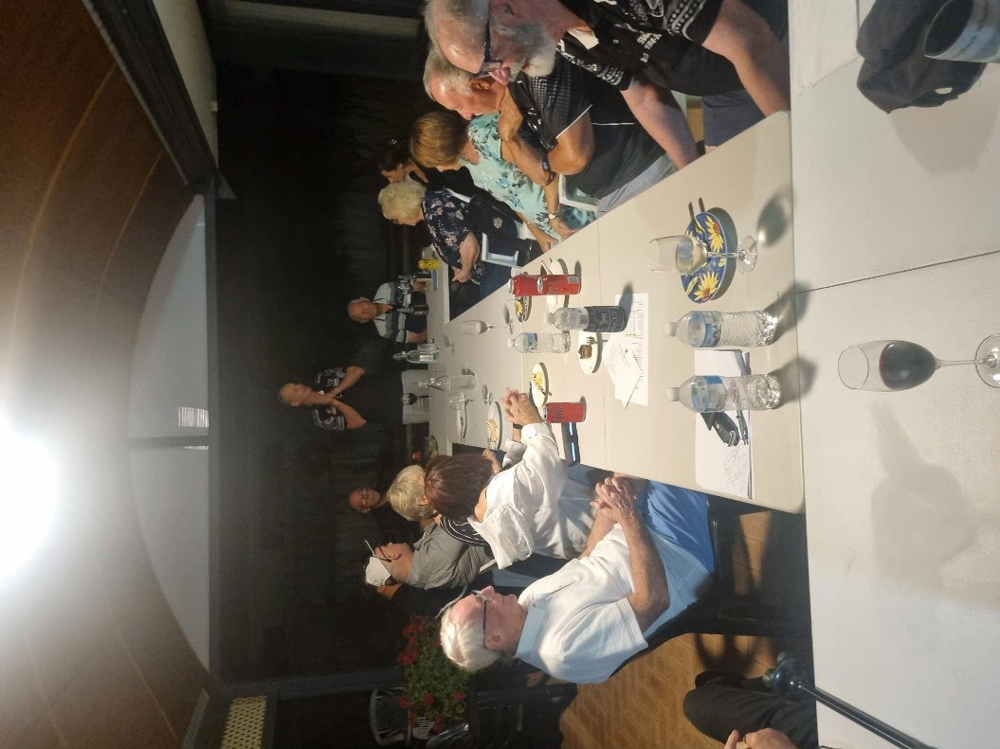
- Men and Women’s Grand Final incentive scheme.
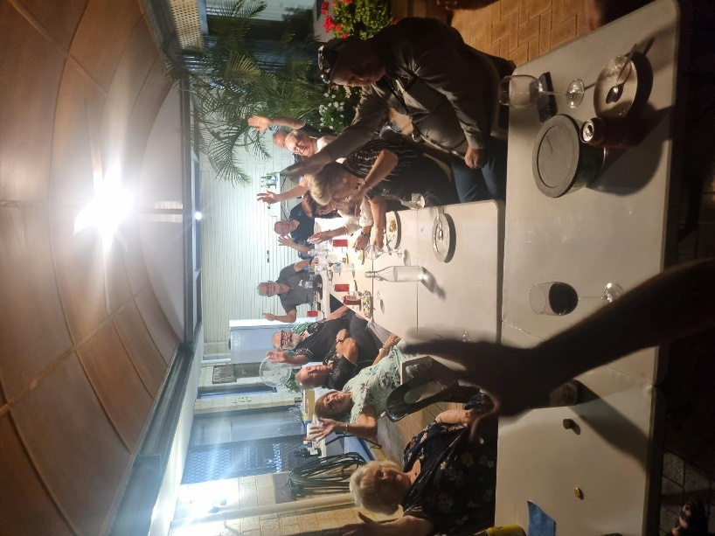
Members and partners enjoying the after-Seminar dinner

Men’s Players Auditorium Renovation

The Swansmen were given the task of renovating the men’s player auditorium in the changerooms, based on a vision by League coach Andrew Pruyn. Works included the demolition of unwanted items, installing a new timber stud frame on the east wall, including gyprocking, flushing and sanding and levelling the floor in the entrance of the room. The ceiling and north wall were painted black while the other three walls were painted white to accommodate motivational murals of all eight premierships. Building work commenced on Wednesday 11th February and was complete Friday 13th February. Painting commenced on Monday 23rd February and completed Tuesday 24h February. The murals are a work in progress and should be installed by the first home game. A big thanks to Gary Cox for organising material, co-ordinating the works and doing most of the grunt work, Scott Howard for the painting, including donation of the paint and Des Hardiman for design and co-ordination of the wall murals, your efforts are greatly appreciated.
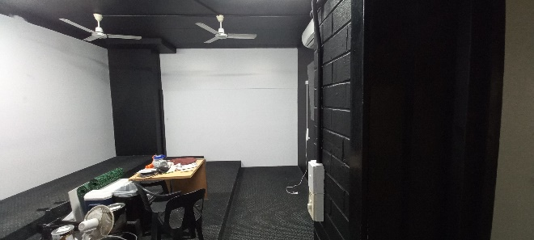
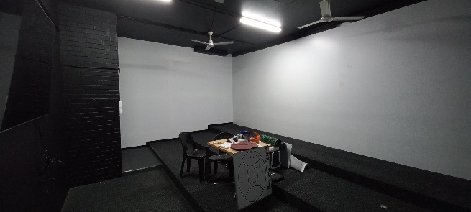

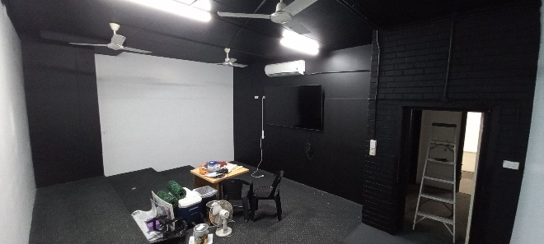
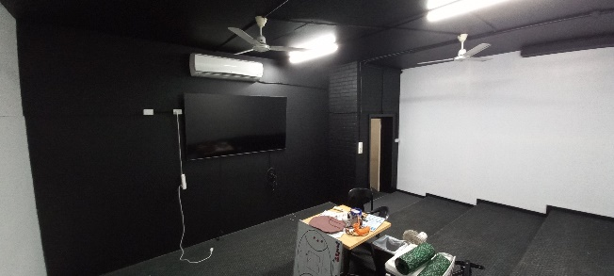

Women’s Changeroom Renovation
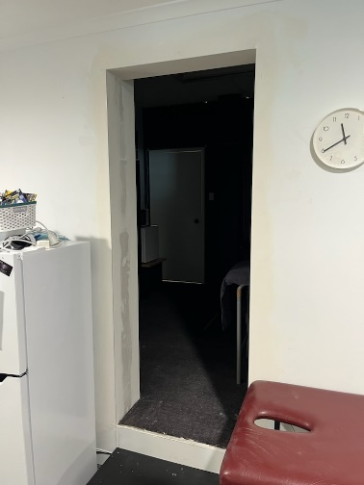
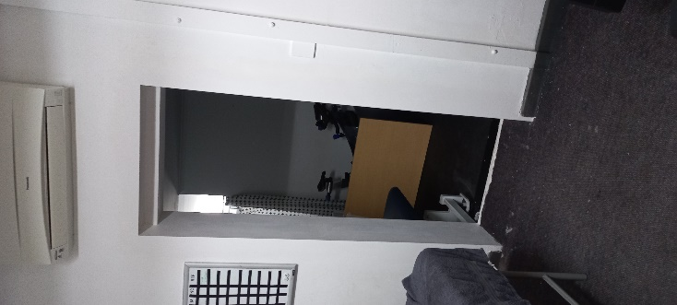
The Swansmen were also given the task of reinstating a doorway in the wall between the women’s changerooms and the recently acquired treatment room from the on-site physio. Works included the demolition of the wall material covering the existing doorway, making good the door opening by gyprocking, flushing and sanding and the installation of a step between the two rooms. Works commenced on Tuesday 17th February and was complete Friday 20th February. A big thanks again to our resident chippie Gary Cox for co-ordinating the works and doing most of the grunt work, his efforts are greatly appreciated, AGAIN.
Door opening looking from rub down room
Door opening looking from changerooms

Coming Events
Date | Event | Time | Venue/ Guest | Guest Speaker
Thursday 5th March | 1st Members Night | 5:00pm | Presidents Suite
Wednesday 11th March | Women's Season Launch | 6:30pm | Presidents Suite
Friday 13th March | SDFC Golf Day | 8:15am | Vines Resort
Tuesday 17th March | DINNER MEETING 1 | 6:30pm | PPOA Room | Andrew Pruyn and Jason Burton
Thursday 19th March | Men's Season Launch | 6:30pm | Presidents Suite
Sunday 22nd March | Lounge Busy Bee | 9:30am | SDFC
Friday 28th March | WAFLW 1st GAME - SD vs CL | 4:00pm | Revo Fitness Stadium
Friday 3rd April | WAFL 1st GAME - SD vs SF | 2:30pm | Steel Blue Oval
Tuesday 7th April | Committee Meeting | 6:00pm | Swansmen Lounge
Tuesday 21st April | DINNER MEETING 2 | 6:30pm | PPOA Room | TBC
Wednesday 13th May | DINNER MEETING 3 | 6:30pm | Mandoon Estate | TBC

Committee 2026

President: Trevor Hoy 0405 453 042 president.swansmen@gmail.com
Vice President: Tim Outred 0403 337 996 timbo63@live.com.au
Secretary: Kim Doust 0410 570 723 secretary.swansmen@gmail.com
Treasurer: Mark Hocking 0452 651 564 xbmcvb@gmail.com

Committee: Neville Bassett 0402 318 846 njb@westarcapital.com.au
Steven Bakes 0477 666 775 ssbakes@bigpond.com
Jim Benson 0405 713 978 jamesbensonlidholm@gmail.com
Darryl Crotty 0422 375 456 dccrotts@icloud.com
Maurice Embley 0431 663 977 maurice.embley@hotmail.com
Steve Grech 0406 167 110 steveandjulie@iinet.net.au
Des Hardiman 0448 792 832 hardiman.des@bigpond.com
Mark McNair 0481 815 647 macka66666@gmail.com
Greg Roberts 0411 417 799 gregroberts@kpfp.com.au
Jim Watterston 0403 340 500 jim.actdet@gmail.com

