***Topsie Turvey Start***

**Women's Football**

Round three saw the girls at home for the first time versus Subiaco. Poor kicking in front of goals let the Rogers Cup girls down, having 7 more scoring shots than the opposition and losing by only 3 points, 4.9 to 6.0. The League side were behind the 8 ball all day and went down by 24 points. Carys D’Addario continued her good form amassing 24 possessions while Jaime Henry picked up 22 possessions with Tayla Edwards kicking the goal. Round four saw the girls travel down to Mandurah to face the Peel. The Rogers Cup girls were in charge from the first bounce and had it not been for inaccurate kicking the margin would have been more winning 9.13 to 6.7. The League started slowly, not scoring in the first quarter, but got back into it in the second term going into the half time break 5 points down, 2.4 to 1.5, inaccurate kicking for goal letting them down. The premiership quarter saw Swans breakout kicking 3.1 to 0.1 and even though Peel kicked 2.1 to 1.1 in the final quarter Swans managed to hold onto a 7-point win. Carys D’Addario was again prominent amassing 30 possessions while Isabella Edgely picked up 31 possessions with Kayle King kicking two goals. Round five was back at home against West Perth in a split round with the League playing on Saturday before the men’s League and the Rogers Cup playing Sunday. In a tight tussle all day, the Rogers Cup girls went into the last break trailing 2.5 to 3.3. A strong last quarter saw Swans kick 3.1 to 1.1 and clinch an 8-point victory. The League game a tight tussle all day, with scores tied at 4.2 a piece at the long break. Swans came out in the third and kicked 2.1 to 0.2 to take an 11-point lead into the last break. West Perth kicked 1.3 to 0.3 in the last but it wasn’t enough with Swans taking the win by 5 points. Carys D’Addario continued her good form amassing 25 possessions while Kayle King picked up 23 possessions and Jaime Henry 22 with Tayla Edwards kicking two goals. So, after Round five the League are third on while the Rogers Cup girls sit fourth on percentage, with the top five sides all on 12 points.

**Men's Football**

It has not been the start the League were looking for with big loses to West Perth at home and East Perth away in Rounds 1 and 2 and then narrow losses to South Fremantle away and Peel at home in Rounds 3 and 4, both winnable games. In the Souths game, after trailing by 17 points at half time, Swans kicked 1.6 to 3.0 in the third and then 4.1 to 2.1 the final term but it wasn’t enough to get the win going down by 11 points. Jye Chalcraft picked up 29 possessions, Josh Cipro 24 and Jesse Turner 23 with Ben Hewitt and Evan Smith kicking two goals each. Peel jumped out of the blocks kicking four goals against the breeze before Swans managed to peg back two before the first break. Peels dominance continued in the second term kicking 2.5 to 1.2 to take a 20-point lead into the long break. Swans came out in the third with a bit of gusto and if not for inaccurate kicking, 2.7 to 0.2, would not have been 3 points down at the last break. The last term was a slog with Swans hitting the front with minutes to go but an unforced error gave Peel an easy goal and the win by 5 points. Zane Trew in his debut game picked up 24 possessions along with Jye Chalcraft and Jesse Turner. The Reserves fortunes have changed from last year winning all four games while the Colts are two and two. So, after round four the League are still winless at the bottom of the ladder, the Reserves sit top and the Colts have dropped to seventh.

**All Abilities Football**

The All-Abilities season kicked off on Saturday 26th April with Swans having a bye.

**Trevor Hoy (President)**



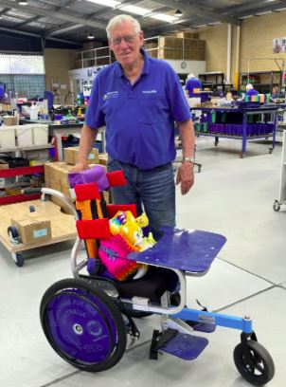***MAY DINNER MEETING***

***Wednesday 14th MAY 2025 6:30pm***

***This is a combined Swansmen Dinner and SDFC Sponsors and Judda Bee Networking Event to be held at Mandoon Estate in the Swan Valley. The cost will be $55 per head and includes food and drinks. The Club have subsidised the Swansmen $25 per head. This is a great opportunity to get to know the Club sponsors as well as Judda Bee members.***

**GUEST SPEAKER**

***Brother Olly Pickett AM – 2025 Senior Australian of the Year***

**B**r. Olly Pickett co-founded *Wheelchairs for Kids* in 1996 to provide adjustable wheelchairs and occupational therapy expertise for children in developing countries. Since then, more than 60,000 custom built wheelchairs have been built in the Malaga workshop and gifted to children in over 80 countries.

Olly won the West Australian Senior of the Year in November 2024 and then went to the Australian Awards in Canberra in January where he received the 2025 Senior Australian of the Year from Prime Minister Albanese - and alongside 2025 Australian of the year Neil Daniher.

With over 250 retiree workshop volunteers, *Wheelchairs for Kids* is one of WA’s largest volunteer led charities – with an average age of 74. Olly has spearheaded the development of an innovative, low-cost wheelchair design to World Health Organisation standard that grows with the growth of the child.

**Swans are proud and privileged to have such a distinguished and recognised great Australian, as our guest at the Networking night. Please invite your friends, family and guests along to hear his inspirational story. A collection will be taken on the night to donate to Wheelchairs for Kids.**

***Numbers must be confirmed before Wednesday 7th May by one of the following methods:***

*RSVP via the online link at* [**RSVP**](https://docs.google.com/forms/d/e/1FAIpQLSd8TLLuyEY2g0r7ml-lXZB5WdDb2zpFn1E7eb_KxmSiZrIlMQ/viewform?usp=header)*or phone Trevor Hoy on 0405 453 042*

As this is a combined Club event payment via EFT to the Swansmen bank account would be preferable. Swansmen bank account details are, BSB: 036-080 A/C: 276254, include your name and event.

**Invite a Guest**

**W**e ask all members to RSVP to the dinners early and we ask that you endeavour to bring along a guest so that we get good numbers and increase our profile.

***Membership Drive***

**A** reminder for those who have not renewed their membership to please do so. An email was sent out in February. Subscriptions have remained at $35 and can be paid by any of the following methods:

* Pay at the Club Office (together with your Club Membership) and add the Swansmen membership
* Pay online via the Club webpage
* Pay at the first Dinner Meeting
* Pay direct to the Swansmen bank account, BSB: 036-080 A/C: 276254, include your name.

***April Dinner Meeting***

* **L**eague players Connor Blakely and Troy Yukich gave an insight into their football journey thus far and what brought them to Swans in the first instance and enticed them back.
* **T**he Guest Speaker for the night was Craig Serjeant,former WA and Australian Cricketer. Interviewer extraordinaire Des Hardiman fired the mainly cricket career questions to Craig who answered very candidly and added a few ‘locker room only’ tales. Of course, the questions came thick and fast from the members after the interview was complete.
* **T**he dinner raffle was drawn by Ross Fitzgerald with Trevor Winnett taking out the prize.

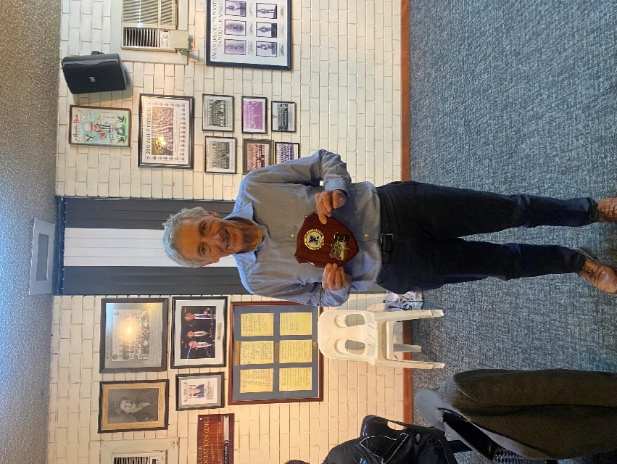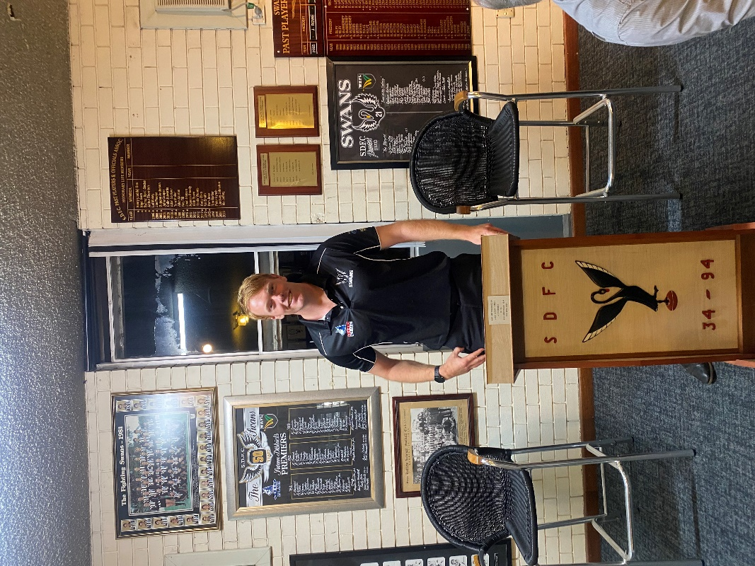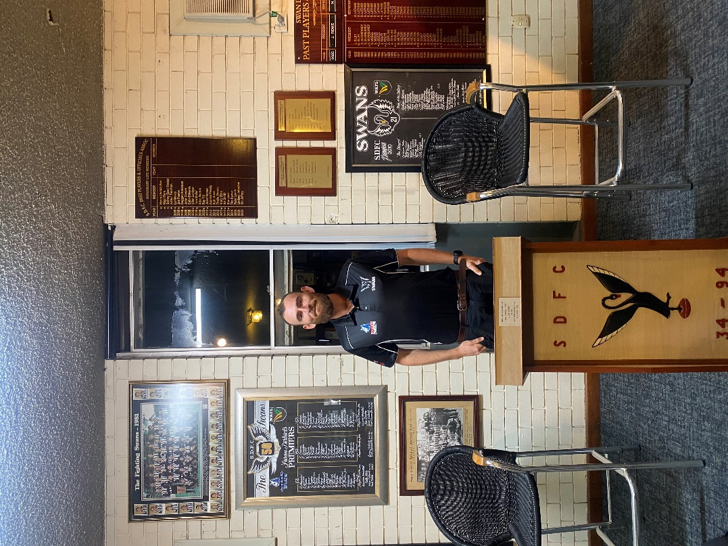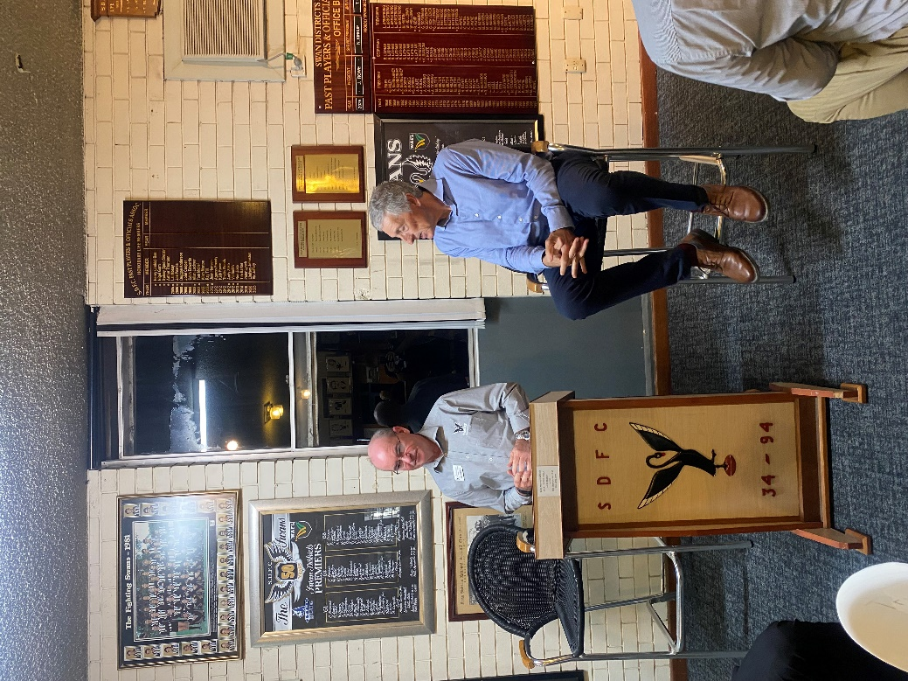

Connor Blakely

Troy Yukich addressing the members

Craig with his Guest Speaker Shield

Des Hardiman interviewing Craig Serjeant

***Thursday Night – Swans Members Night***

**A**ll Club Members and Supporters are invited to Steel Blue Oval on Thursday nights to watch the team train and then join in the following activities in the main bar:

**Chase the Ace – The jackpot as of Thursday 24th April is $1,755.**

**Free Members Draw – The jackpot as of Thursday 24th April is $1,800. The lucky member must be in attendance and claim the prize within 2 minutes – otherwise a jackpot of $100 is added.**

***Fundraising for 2025***

**The retraVision Swansmen Auction** – **WE NEED YOUR HELP AND DONATIONS**

On-line event only again. Will run the entirety of August. The Club is on board again to make this the big fundraiser for the season. The Auction site should be up and running mid-July.

Watch this space, the Club website and your inbox for further details.

**3 ways YOU can help make the Auction a HUGE success and add to our donation to the Club at year end:**

1. Drop into a known business or restaurant near you and ask for a donation to the auction by way of a product or voucher.

2. Seek a wine maker or donate a carton of wine for the wine wall.

****3. Donate $20, $50 or $100 to our ‘Good Guys’ pool of funds for us to purchase additional home products for the auction catalogue.

**AFL Grand Final/Cash Bonanza Raffle** - Tickets on sale now and are selling fast. The winner will be drawn at the July dinner. Price is $100 each and will be restricted to just 200. Major prize is the choice of a return trip for 2 to the 2025 AFL Grand Final or $5000 cash. There will also be a second prize of $300 plus 20 consolation prizes of your money back. See Peter Snow or Committee for tickets.

**Sponsor A Picket** - This is your chance to share in a unique piece of Western Australian sporting history. The sponsored picket could be a birthday gift, memorial remembrance for a loved one, personal favourite spot, or just a tribute to the great memories over the years at Bassendean Oval. Your choice of location around the ground. **Only $150.00**

**The Player Auction Leader Board** - the current standings for the Men's teams after Round 2 are as follows:

|  |  |  |
| --- | --- | --- |
| ***GROUP*** | ***NAME*** | ***EARNINGS*** |
| 1 | Celebrations Maida Vale | $639.72 |
| 2 | Swansmen | $845.34 |
| 3 | ABM Landscaping | $0.00 |
| 4 | Graeme Yukich | $0.00 |
| 5 | Iron Mine Contracting | $308.43 |
| 6 | Directors | $308.43 |
| 7 | PP&OA | $0.00 |
| 8 | Celebrations Maida Vale | $0.00 |
| 9 | Midway Ford | $0.00 |
| 10 | Unique Cutting | $205.62 |

***Coming Events***

|  |  |  |  |  |
| --- | --- | --- | --- | --- |
| ***Date*** | ***Event*** | ***Time*** | ***Venue/ Guest*** | ***Guest Speaker*** |
| ***Wednesday 14th May*** | DINNER MEETING 3 | 6:30pm | Mandoon Estate | **Br. Olly Pickett AM** |
| ***Tuesday 3rd June*** | Committee Meeting | 6:00pm | Swansmen Lounge |  |
| ***Tuesday 17th June*** | DINNER MEETING 4 | 6:30pm | PPOA Room | **Alan (Chubby) Stiles** |
| ***Tuesday 15th July*** | DINNER MEETING 5 | 6:30pm | PPOA Room | TBC |
| ***Saturday 26th July*** | **Hall of Fame Night** | 6:30pm | Presidents Suite |  |
| ***Friday 1st August*** | **On-line Auction** | 12:00am | **www.galabid.com** |  |
| ***Tuesday 5th August*** | Committee Meeting | 6:00pm | Swansmen Lounge |  |
| ***Tuesday 19th August*** | DINNER MEETING 6 | 6:30pm | PPOA Room | TBC |

***Committee 2025***

**President:** Trevor Hoy 0405 453 042 [president.swansmen@gmail.com](mailto:president.swansmen@gmail.com)

**Vice President:** Tim Outred 0403 337 996 [timbo63@live.com.au](mailto:timbo63@live.com.au)

**Secretary:** Steven Bakes 0477 666 775 [secretary.swansmen@gmail.com](mailto:secretary.swansmen@gmail.com)

**Treasurer:** Des Hardiman 0448 792 832 [hardiman.des@bigpond.com](mailto:higginsg@bigpond.net.au)

**Committee:** Neville Bassett 0402 318 846 [njb@westarcapital.com.au](mailto:njb@westarcapital.com.au)

Jim Benson 0405 713 978 [jamesbensonlidholm@gmail.com](mailto:jamesbensonlidholm@gmail.com)

Darryl Crotty 0422 375 456 dccrotts@icloud.com

Kim Doust 0410 570 723 kim.doust@gmail.com

Maurice Embley 0431 663 977 [maurice.embley@hotmail.com](mailto:maurice.embley@dsc.wa.gov.au)

Steve Grech 0406 167 110 [steveandjulie@iinet.net.au](mailto:steveandjulie@iinet.net.au)

Marc Hocking 0452 651 564 xbmcvb@gmail.com

Mark McNair 0481 815 647 [macka66666@gmail.com](mailto:macka66666@gmail.com)

Greg Roberts 0411 417 799 gregroberts@kpfp.com.au